Equality from Congruence

Definition
# Source: AI Source: Provided by: [Data Path: Persons Table -> ID Column: 1, Name_En Column: Motasem Essam] -> From: [ChatGPT] on [7/25/2026]
Equality from Congruence is a geometric equality obtained from the fact that two geometric figures, segments, angles, or other geometric objects are congruent.
Congruent figures have the same shape and the same size. Therefore, their corresponding measurements are equal.
If:
$$\boxed{F_{1}≅F_{2}}$$
then corresponding quantities are equal, such as:
$$\boxed{\text{Corresponding lengths are equal}} \\ \boxed{\text{Corresponding angles are equal}} \\ \boxed{\text{Corresponding areas are equal}} \\ \boxed{\text{Corresponding perimeters are equal}}$$
Simple Definition
Equality from Congruence means using congruence to establish that corresponding geometric measurements are equal.
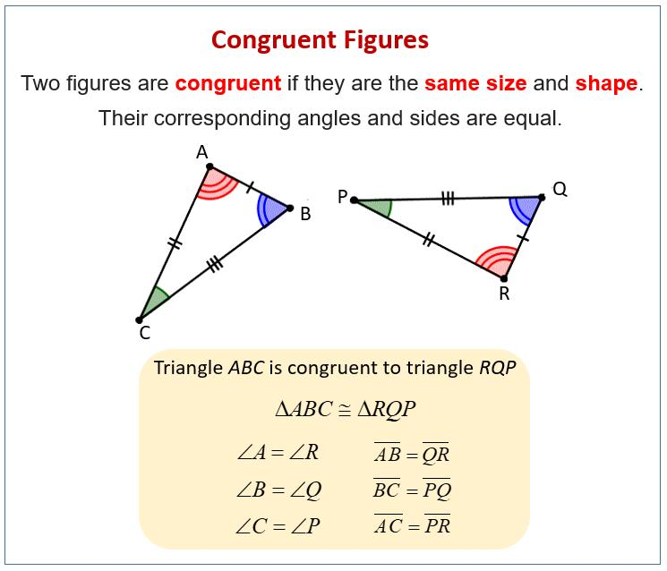
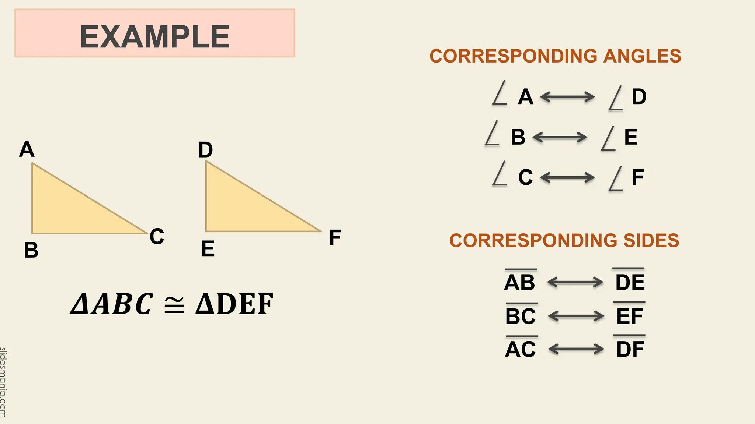
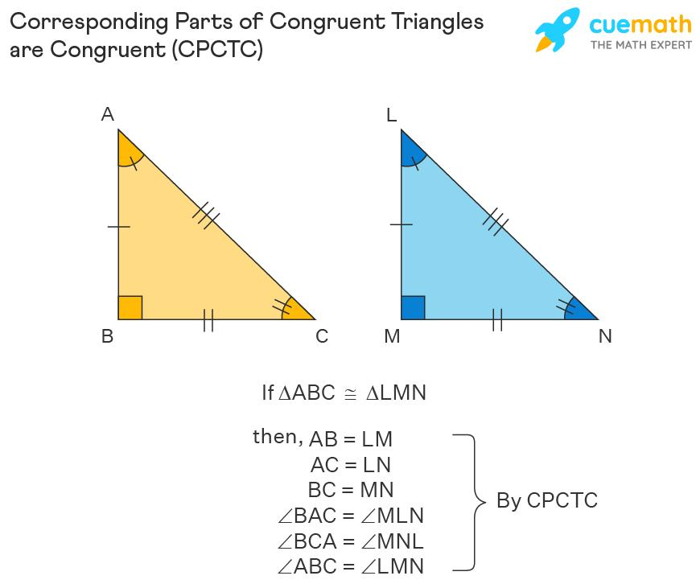
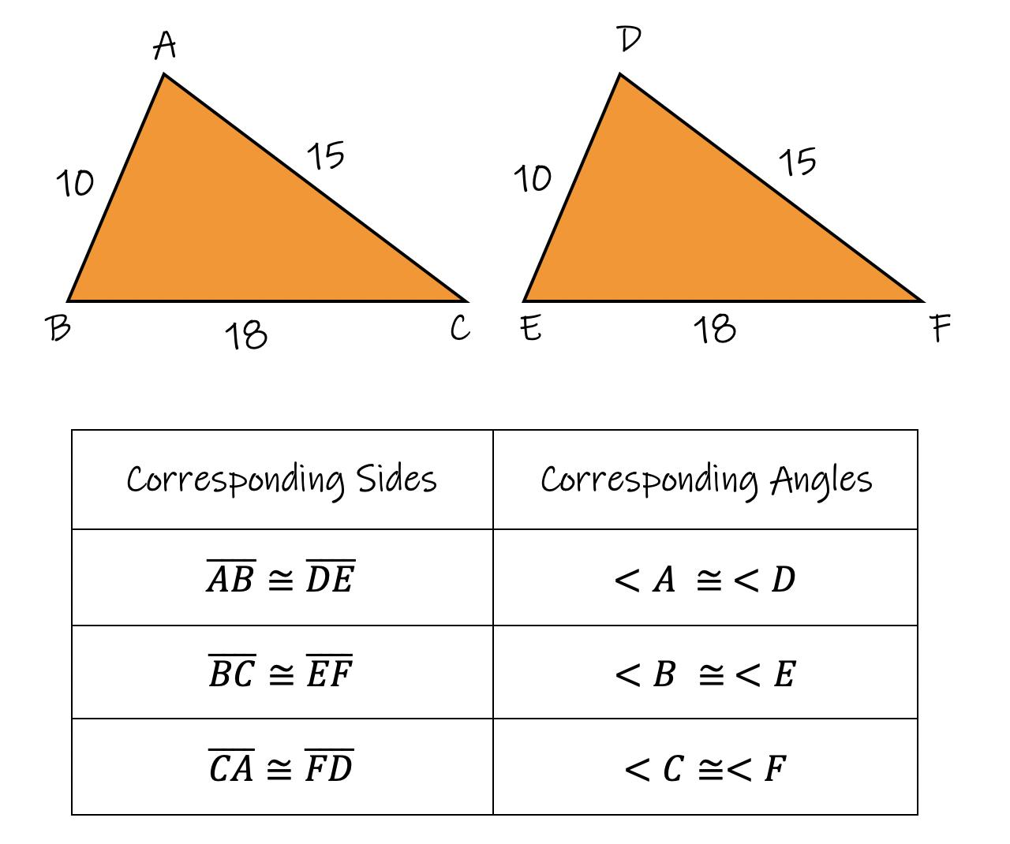

Fundamental Concept
# Source: AI Source: Provided by: [Data Path: Persons Table -> ID Column: 1, Name_En Column: Motasem Essam] -> From: [ChatGPT] on [7/25/2026]
The fundamental principle is:
$$\boxed{\text{Congruence}⇒\text{Equality of Corresponding Measurements}}$$
For example:
$$△ABC≅△DEF$$
means that the correspondence is:
$$A↔D, B↔E, C↔F.$$
Therefore:
$$\boxed{AB=DE} \\ \boxed{BC=EF} \\ \boxed{AC=DF}$$
and:
$$\boxed{∠A=∠D} \\ \boxed{∠B=∠E} \\ \boxed{∠C=∠F}.$$
This is commonly expressed using:
$$\boxed{\text{CPCTC}}$$
Corresponding Parts of Congruent Triangles are Congruent.
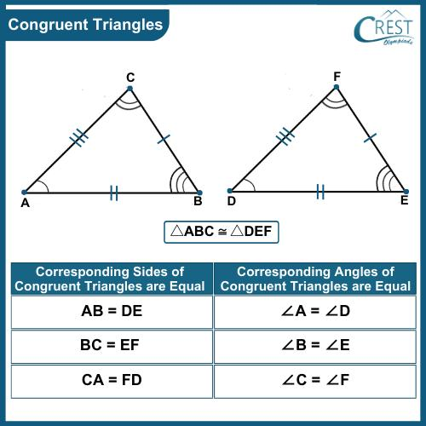
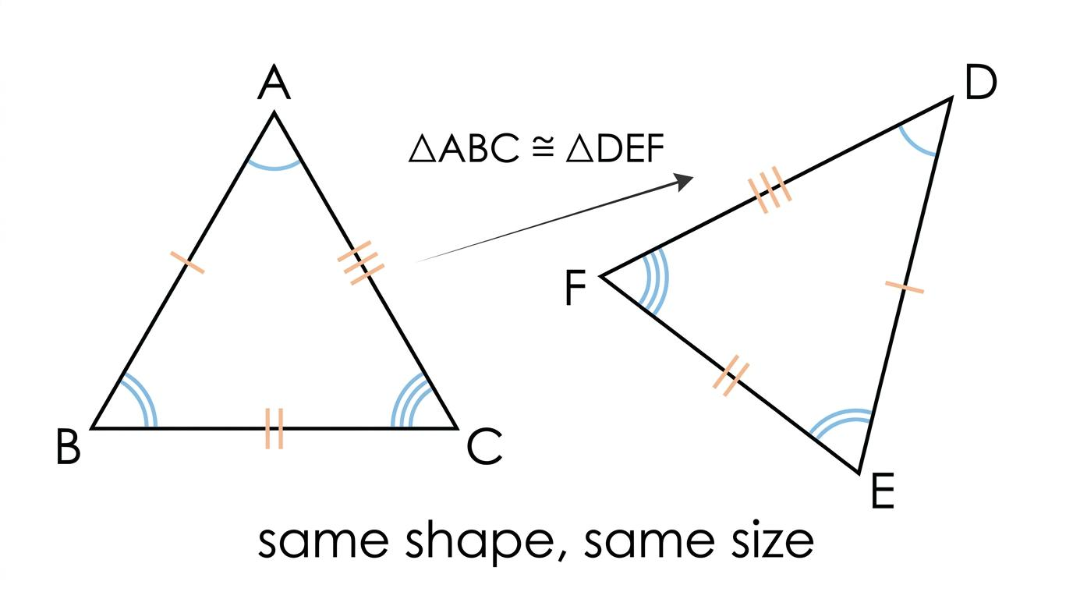
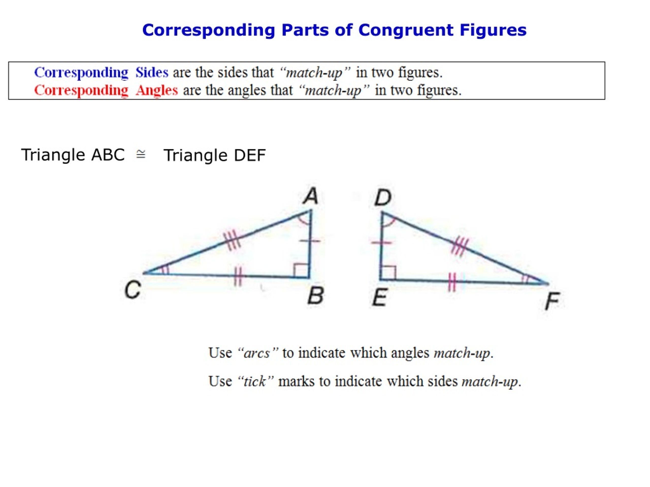
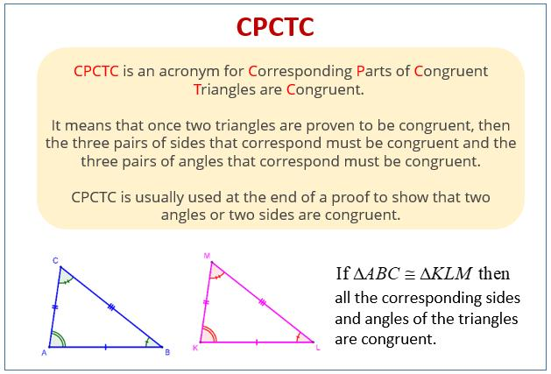

Classification of Equality from Congruence
# Source: AI Source: Provided by: [Data Path: Persons Table -> ID Column: 1, Name_En Column: Motasem Essam] -> From: [ChatGPT] on [7/25/2026]
A practical classification is:
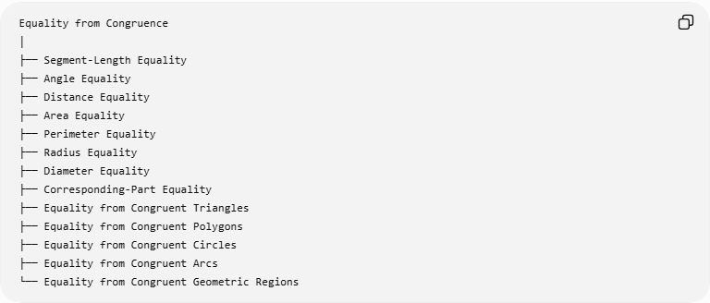
Equality from Congruence
│
├── Segment-Length Equality
├── Angle Equality
├── Distance Equality
├── Area Equality
├── Perimeter Equality
├── Radius Equality
├── Diameter Equality
├── Corresponding-Part Equality
├── Equality from Congruent Triangles
├── Equality from Congruent Polygons
├── Equality from Congruent Circles
├── Equality from Congruent Arcs
└── Equality from Congruent Geometric Regions
This is a practical classification, rather than a universally standardized formal taxonomy.

Equality of Corresponding Segments
# Source: AI Source: Provided by: [Data Path: Persons Table -> ID Column: 1, Name_En Column: Motasem Essam] -> From: [ChatGPT] on [7/25/2026]
If two segments are congruent:
$$\boxed{\overset{‾}{AB}≅\overset{‾}{CD}}$$
then their lengths are equal:
$$\boxed{AB=CD}.$$
Example
Suppose:
$$\overset{‾}{AB}≅\overset{‾}{CD}$$
and:
$$AB=8\text{ cm}.$$
Then:
$$\boxed{CD=8\text{ cm}}.$$
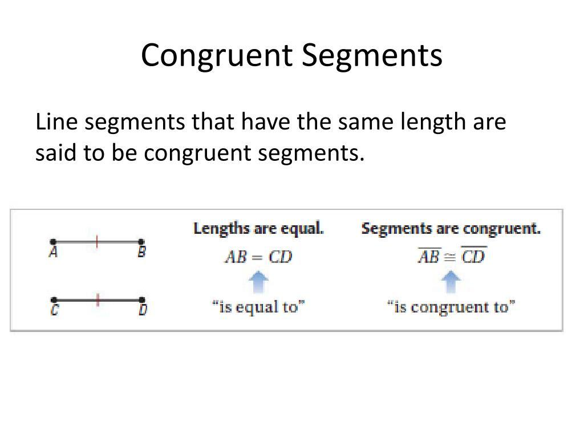
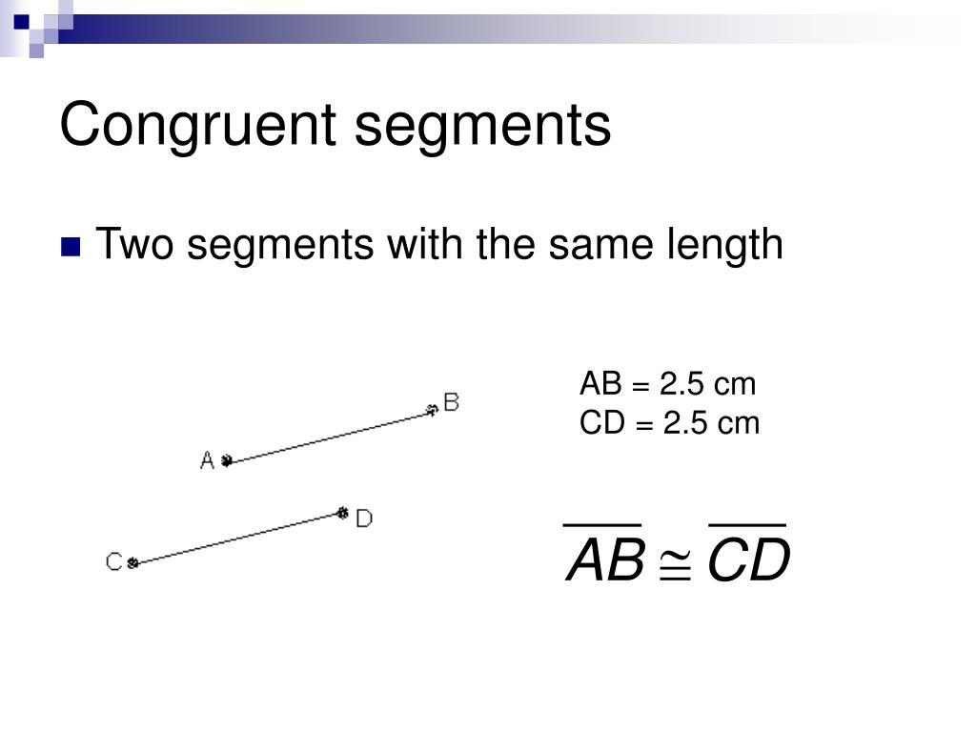
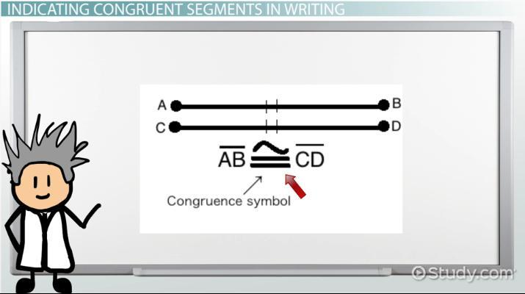
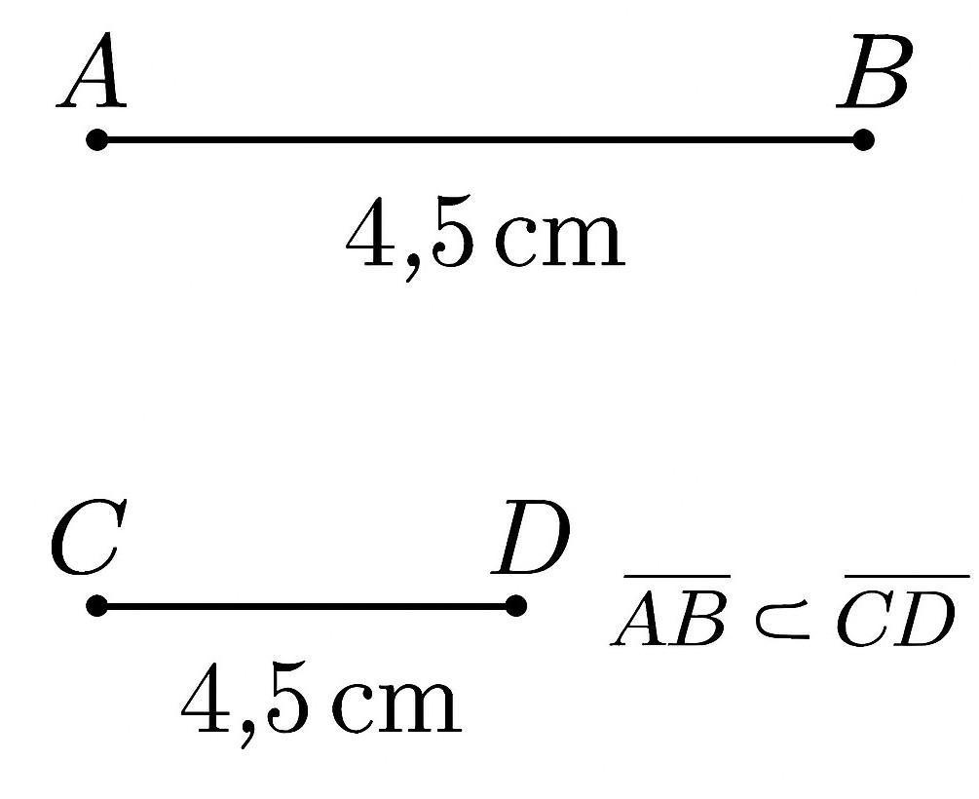
Important distinction
$$\overset{‾}{AB}≅\overset{‾}{CD}$$
describes congruence of segments, while:
$$AB=CD$$
describes equality of their lengths.

Equality of Corresponding Angles
# Source: AI Source: Provided by: [Data Path: Persons Table -> ID Column: 1, Name_En Column: Motasem Essam] -> From: [ChatGPT] on [7/25/2026]
If two angles are congruent:
$$\boxed{∠A≅∠B}$$
then:
$$\boxed{m∠A=m∠B}.$$
Example
If:
$$∠A≅∠B$$
and:
$$m∠A={60}^{∘},$$
then:
$$\boxed{m∠B={60}^{∘}}.$$
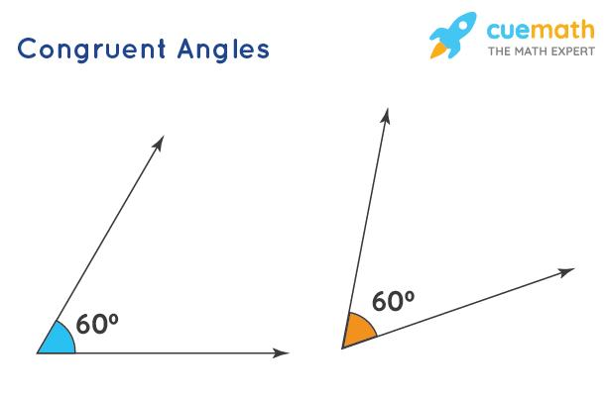
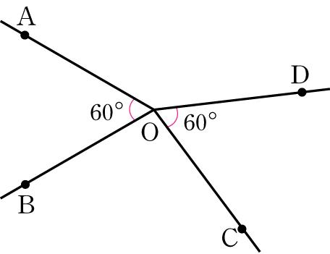
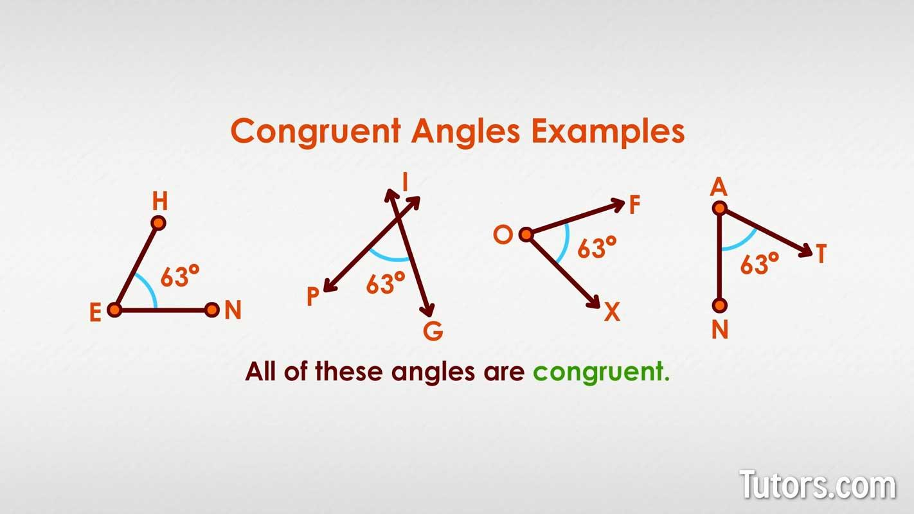
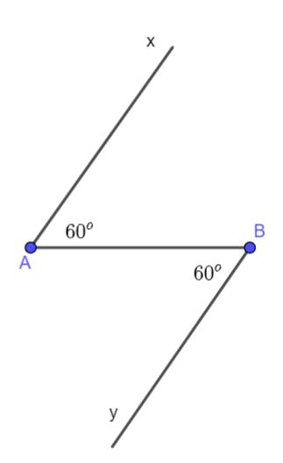
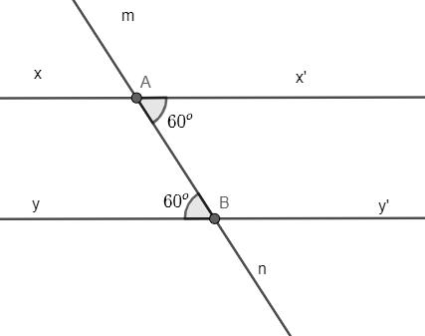

Equality from Congruent Triangles
# Source: AI Source: Provided by: [Data Path: Persons Table -> ID Column: 1, Name_En Column: Motasem Essam] -> From: [ChatGPT] on [7/25/2026]
This is one of the most important applications.
If:
$$\boxed{△ABC≅△DEF},$$
then all corresponding sides and angles are equal.
The correspondence is:
$$A↔D \\ B↔E \\ C↔F.$$
Therefore:
Corresponding sides
$$\boxed{AB=DE} \\ \boxed{BC=EF} \\ \boxed{AC=DF}$$
Corresponding angles
$$\boxed{∠A=∠D} \\ \boxed{∠B=∠E} \\ \boxed{∠C=∠F}.$$
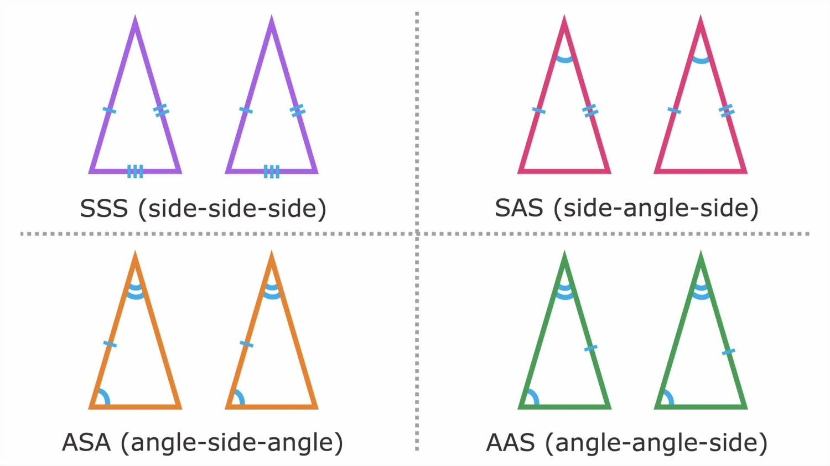
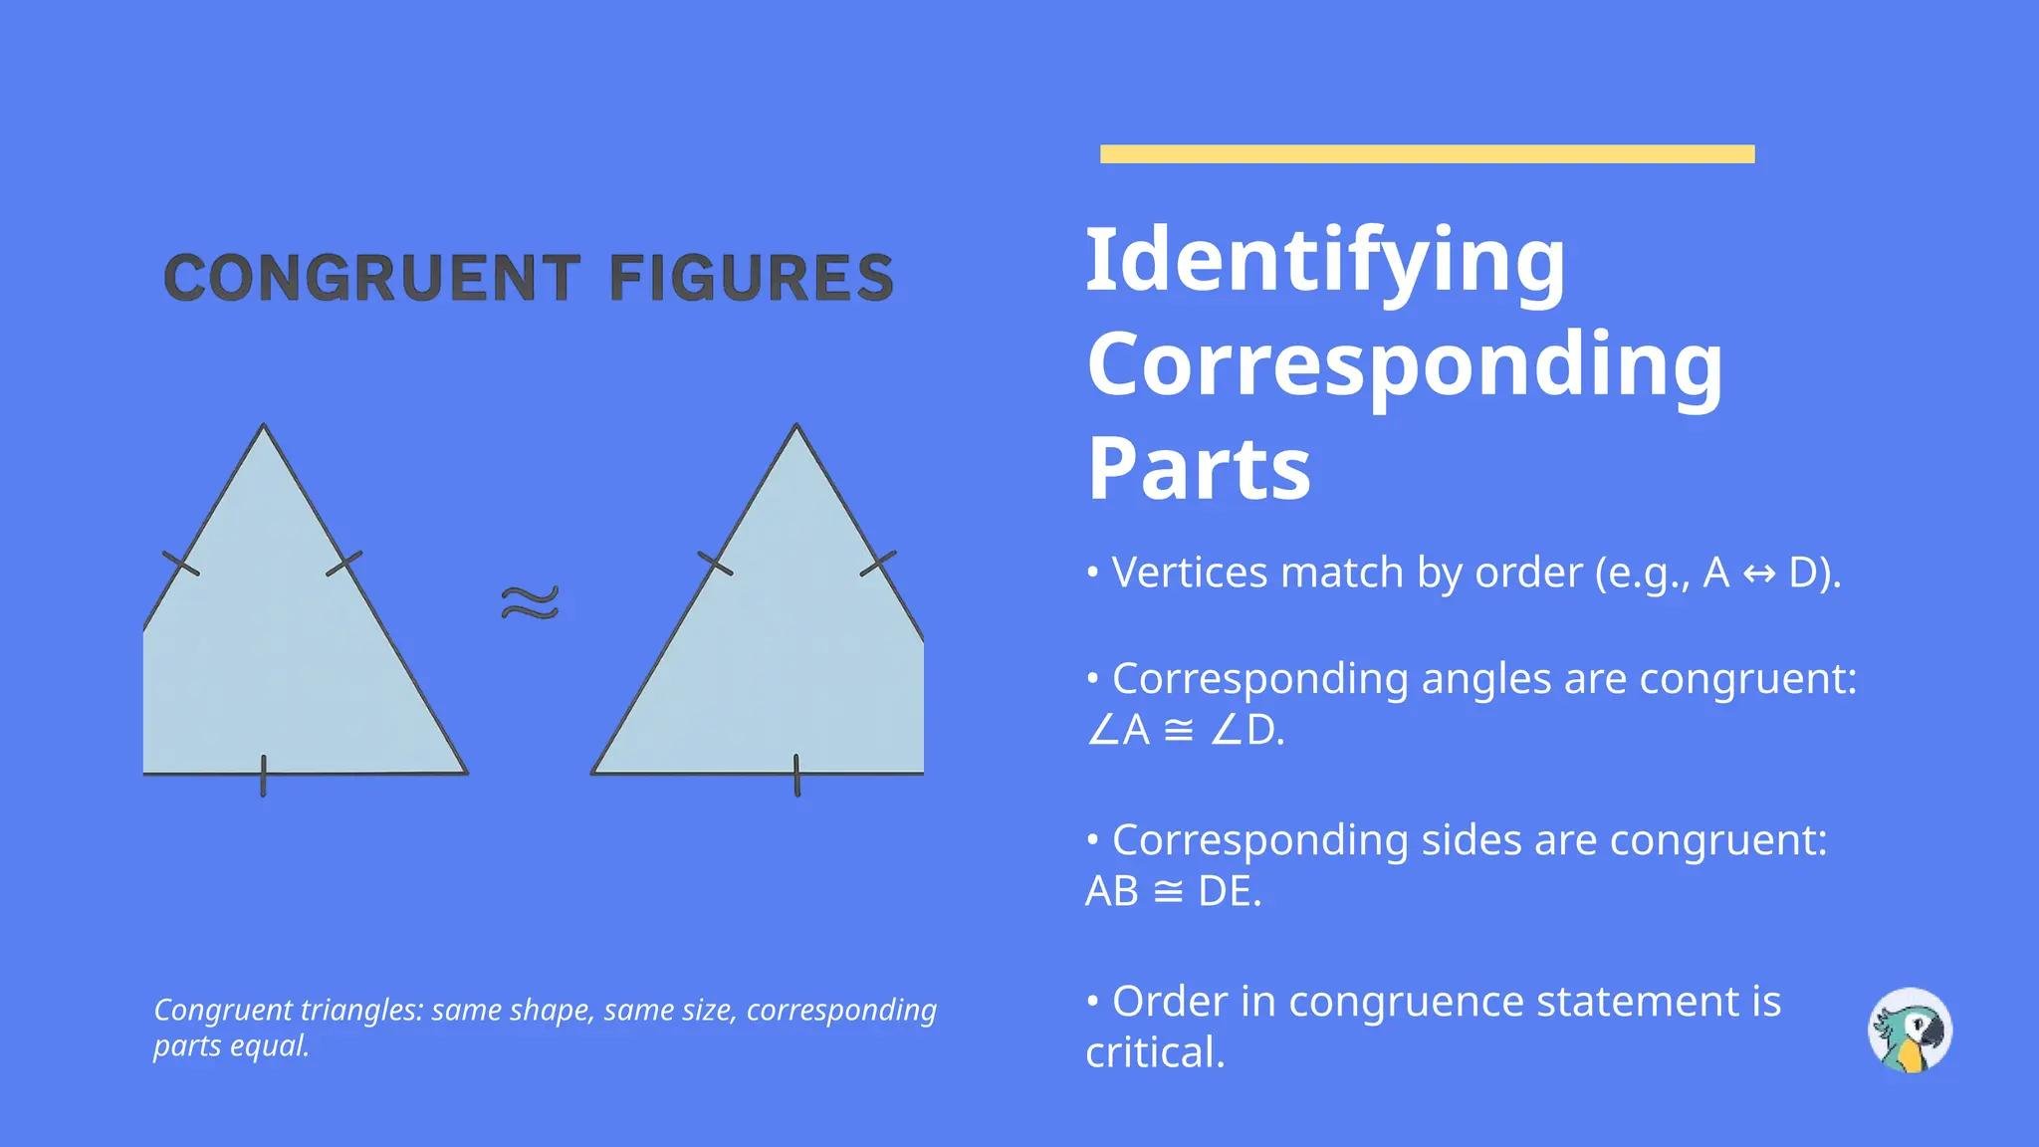

CPCTC
# Source: AI Source: Provided by: [Data Path: Persons Table -> ID Column: 1, Name_En Column: Motasem Essam] -> From: [ChatGPT] on [7/25/2026]
CPCTC is one of the main methods for obtaining equality from triangle congruence.
$$\boxed{\text{Corresponding Parts of Congruent Triangles are Congruent}}$$
Suppose:
$$△ABC≅△DEF.$$
Then CPCTC allows us to conclude:
$$AB=DE$$
and:
$$∠B=∠E.$$
Example
If:
$$△ABC≅△DEF$$
and:
$$AC=12\text{ cm},$$
then, because $AC↔DF$:
$$\boxed{DF=12\text{ cm}}.$$

Equality from the SSS Congruence Criterion
# Source: AI Source: Provided by: [Data Path: Persons Table -> ID Column: 1, Name_En Column: Motasem Essam] -> From: [ChatGPT] on [7/25/2026]
Two triangles are congruent by SSS when their three corresponding sides are equal.
$$\boxed{\text{SSS}=\text{Side-Side-Side}}$$
For example:
$$AB=DE \\ BC=EF \\ AC=DF.$$
Therefore:
$$△ABC≅△DEF.$$
After establishing congruence, additional corresponding angles can be shown equal using CPCTC.
Example
If:
$$AB=DE=5, \\ BC=EF=7, \\ AC=DF=8,$$
then:
$$△ABC≅△DEF$$
by SSS.
Consequently:
$$\boxed{∠A=∠D}.$$
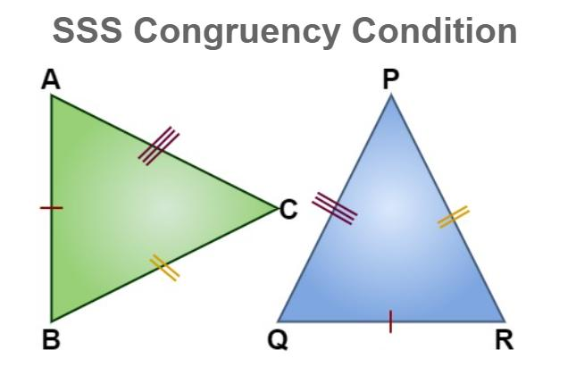
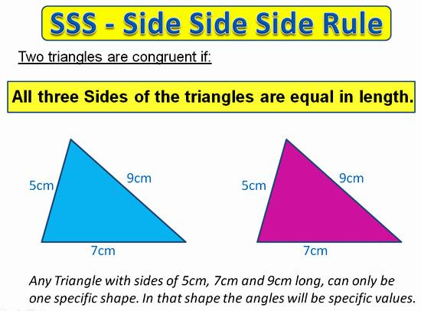
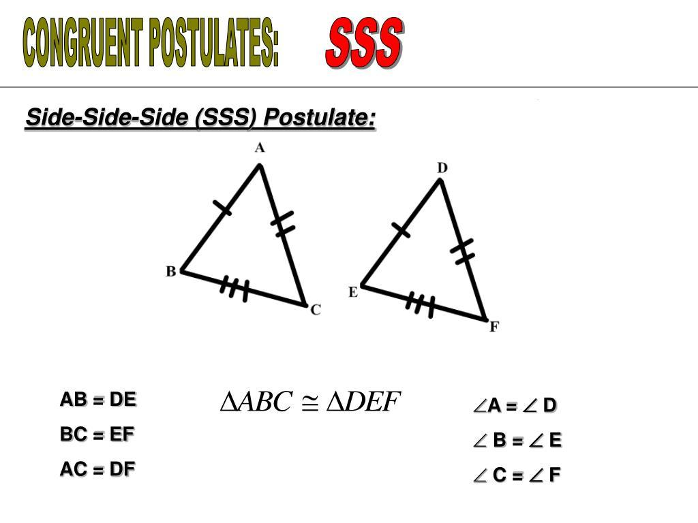
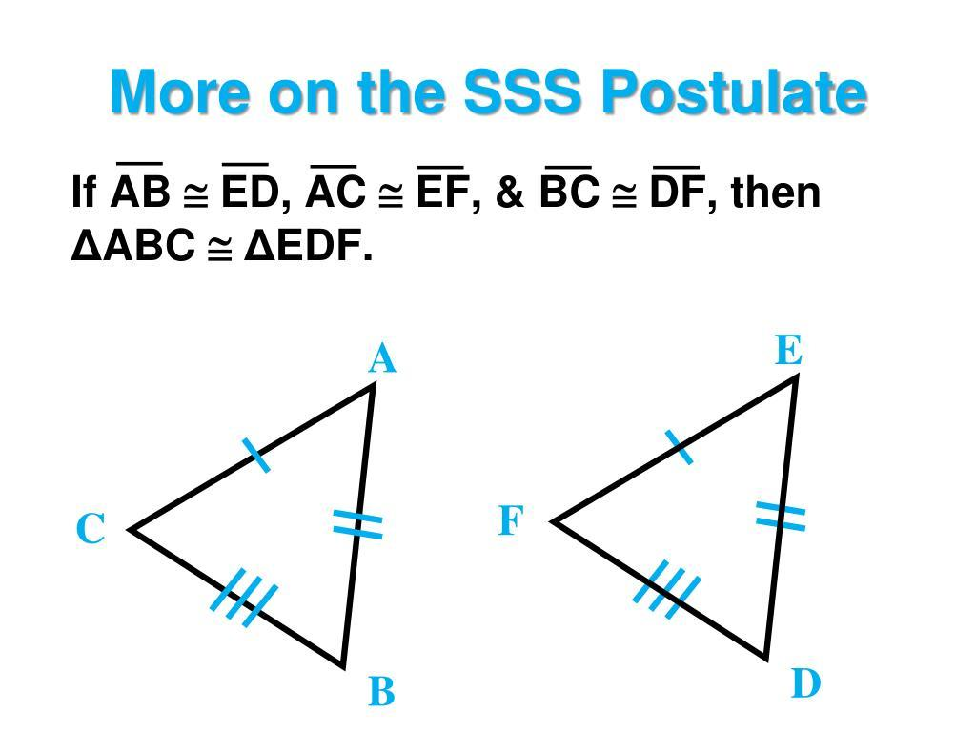
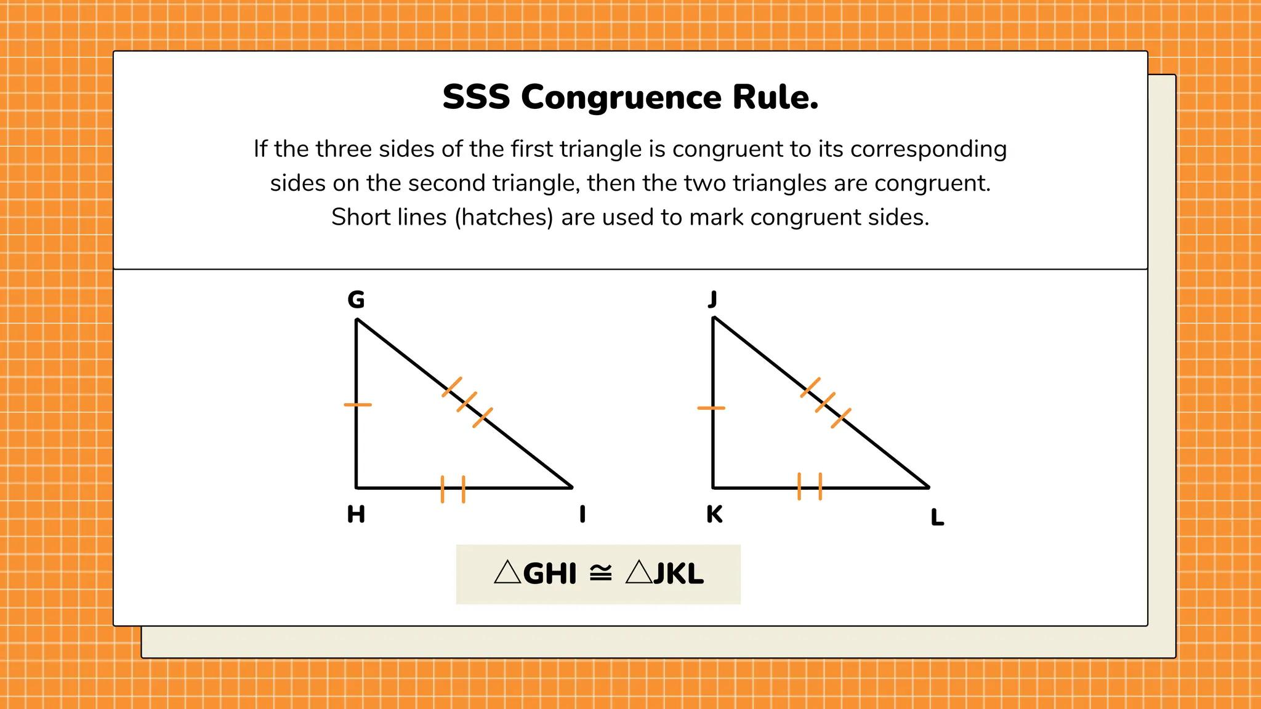

Equality from SAS Congruence
# Source: AI Source: Provided by: [Data Path: Persons Table -> ID Column: 1, Name_En Column: Motasem Essam] -> From: [ChatGPT] on [7/25/2026]
SAS means:
$$\boxed{\text{Side-Angle-Side}}.$$
If:
$$AB=DE, \\ ∠B=∠E,$$
and:
$$BC=EF,$$
then:
$$\boxed{△ABC≅△DEF}.$$
Therefore, CPCTC can establish the remaining equalities:
$$AC=DF$$
and:
$$∠A=∠D.$$
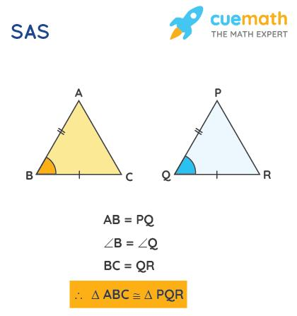
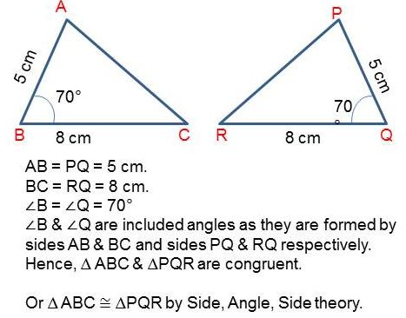
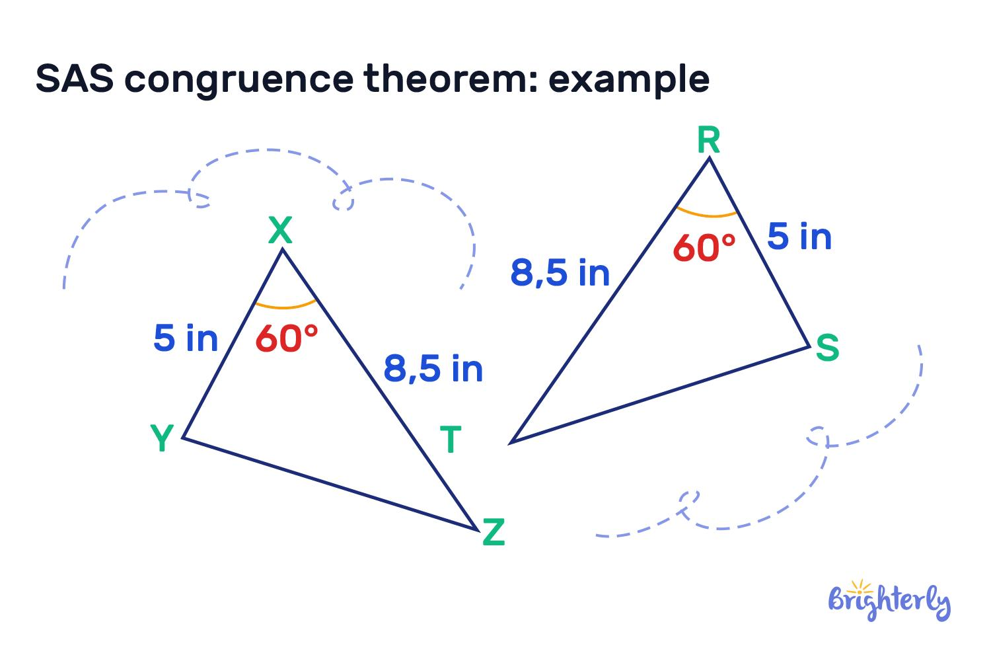
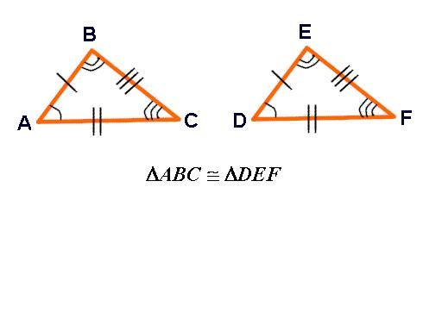
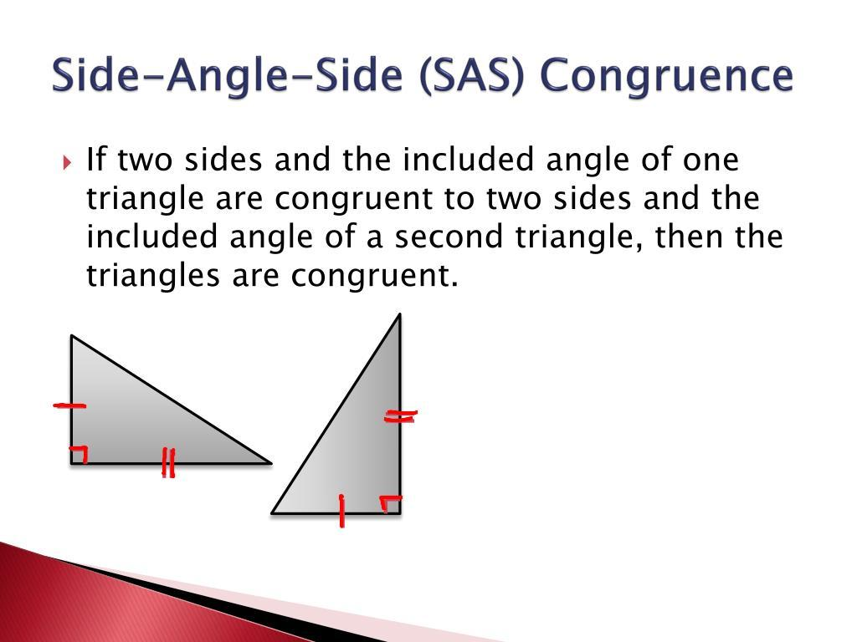

Equality from ASA Congruence
# Source: AI Source: Provided by: [Data Path: Persons Table -> ID Column: 1, Name_En Column: Motasem Essam] -> From: [ChatGPT] on [7/25/2026]
ASA means:
$$\boxed{\text{Angle-Side-Angle}}.$$
If:
$$∠A=∠D, \\ AB=DE,$$
and:
$$∠B=∠E,$$
then:
$$△ABC≅△DEF.$$
Therefore:
$$\boxed{AC=DF}$$
by CPCTC.

Equality from AAS Congruence
# Source: AI Source: Provided by: [Data Path: Persons Table -> ID Column: 1, Name_En Column: Motasem Essam] -> From: [ChatGPT] on [7/25/2026]
AAS means:
$$\boxed{\text{Angle-Angle-Side}}.$$
If two corresponding angles and a corresponding non-included side are equal, the triangles are congruent.
Once congruence is established:
$$\boxed{\text{all corresponding sides and angles are equal}}.$$

Equality from RHS / HL Congruence
# Source: AI Source: Provided by: [Data Path: Persons Table -> ID Column: 1, Name_En Column: Motasem Essam] -> From: [ChatGPT] on [7/25/2026]
For right triangles, the RHS or HL criterion can establish congruence.
It uses:
- Right angle
- Hypotenuse
- One corresponding leg
If two right triangles are congruent:
$$△ABC≅△DEF,$$
then their corresponding sides are equal.
For example:
$$\boxed{AB=DE}.$$
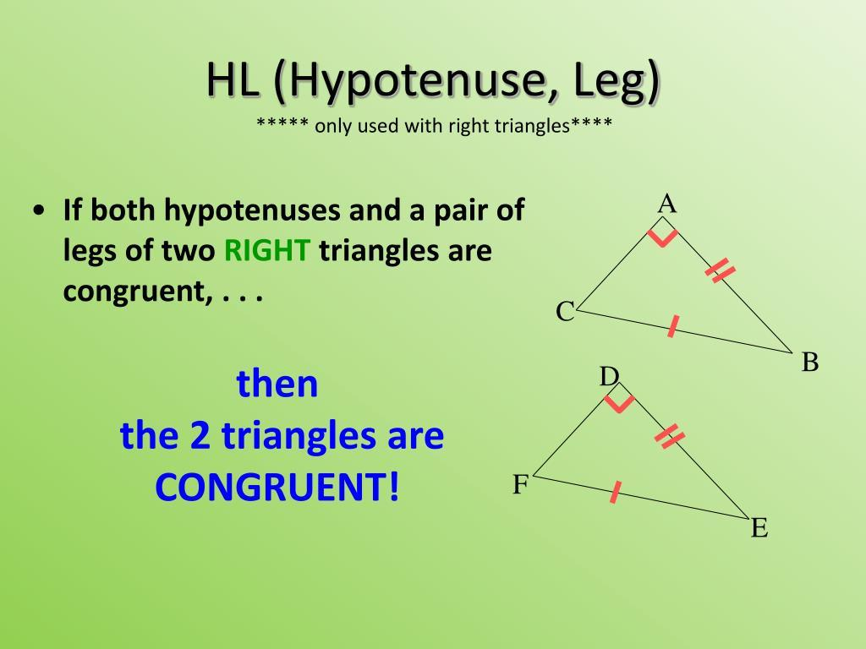
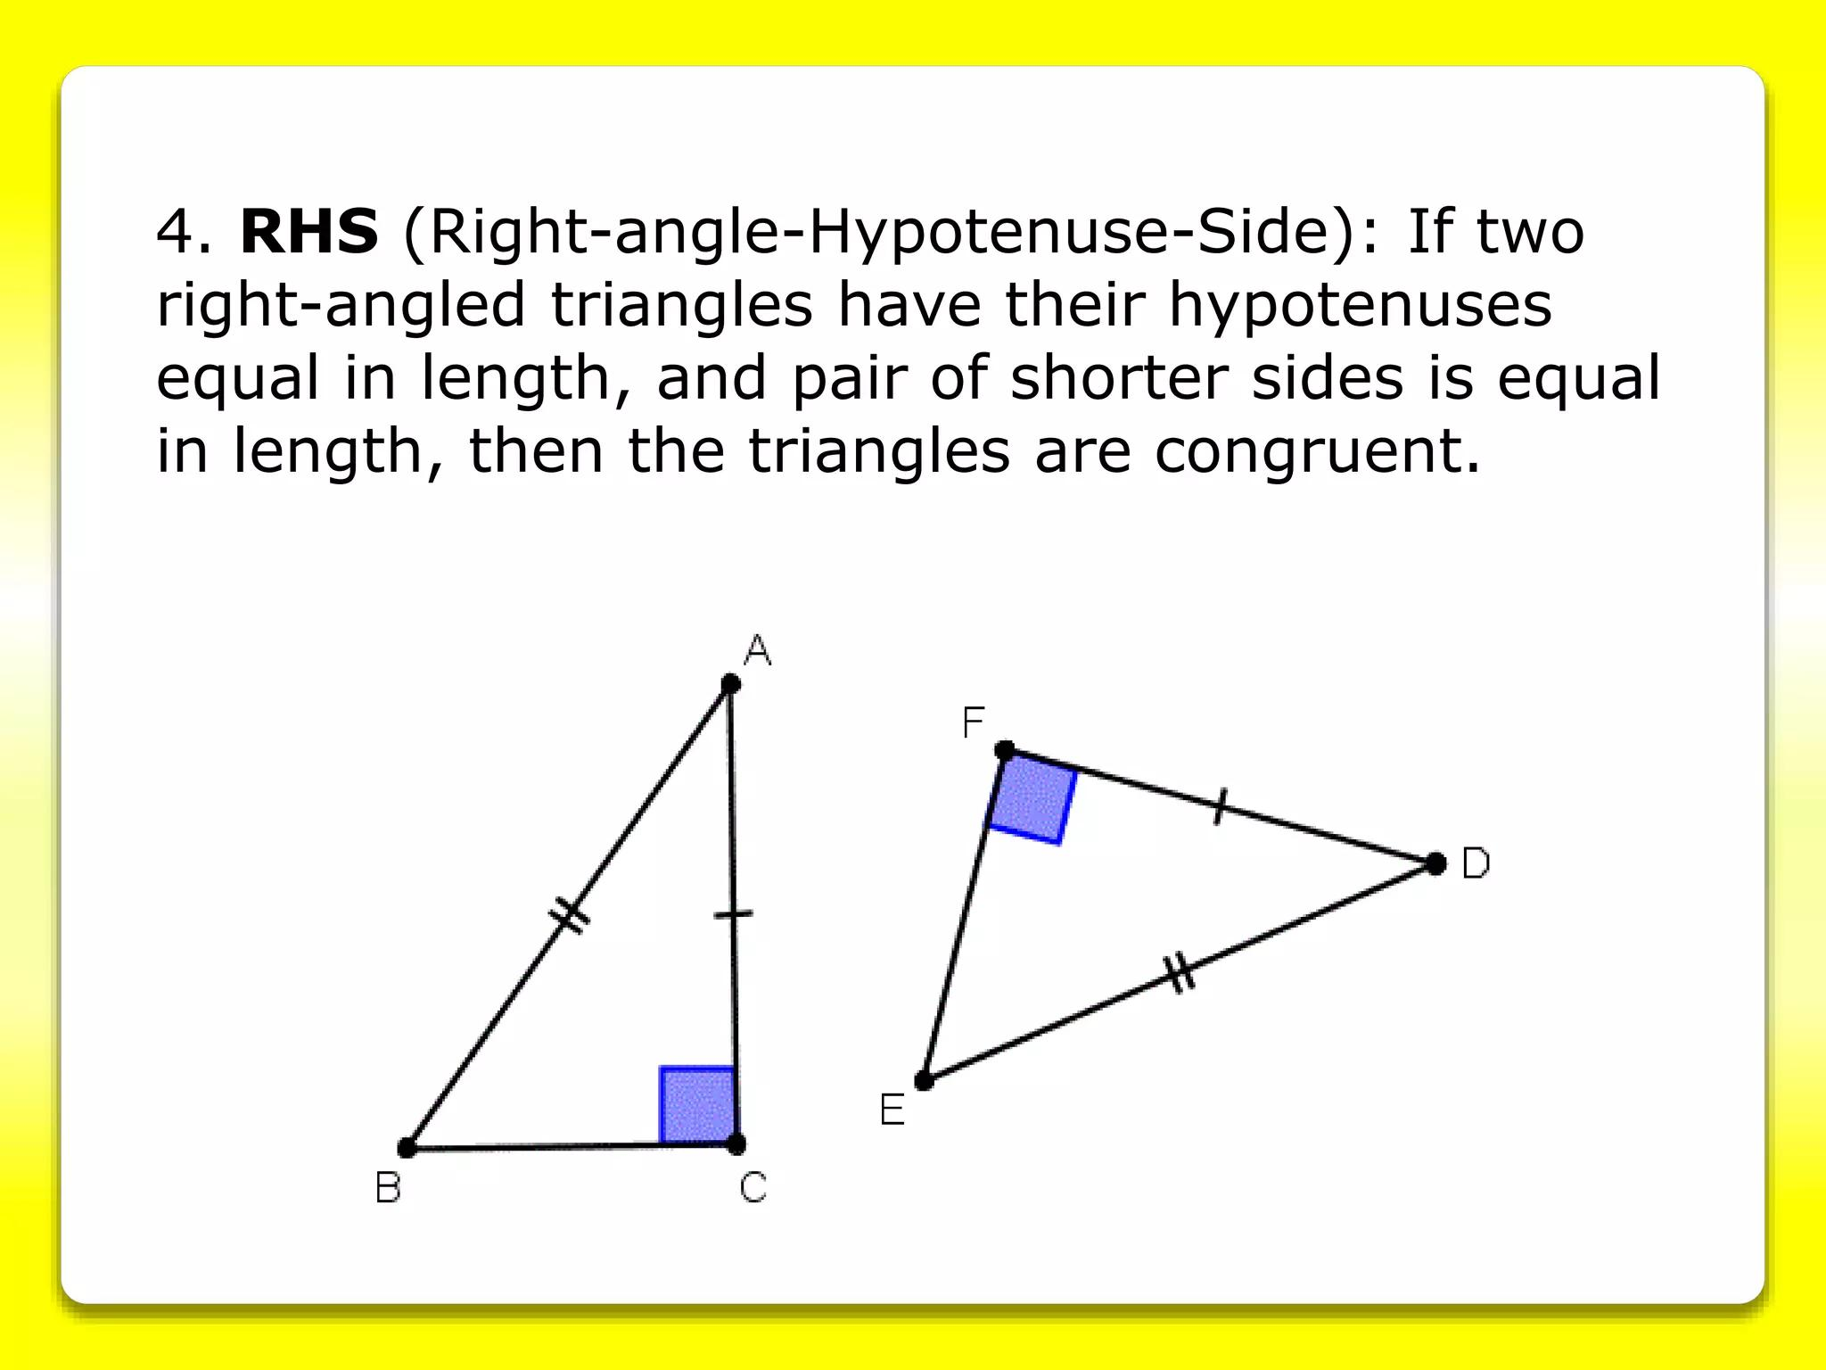
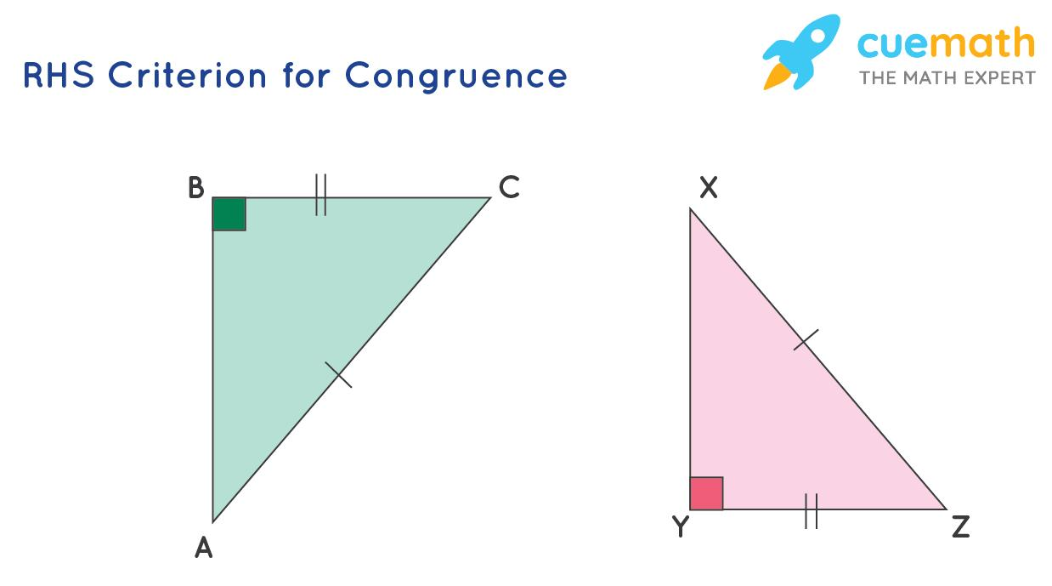
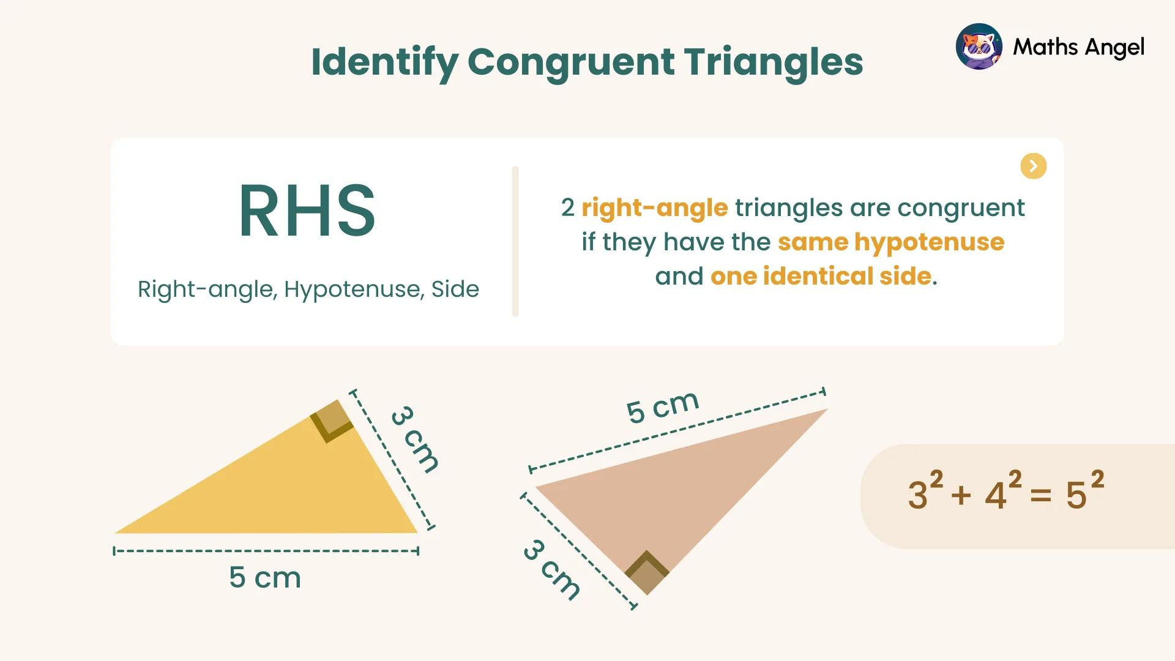

Equality from Congruent Polygons
# Source: AI Source: Provided by: [Data Path: Persons Table -> ID Column: 1, Name_En Column: Motasem Essam] -> From: [ChatGPT] on [7/25/2026]
Congruence is not limited to triangles.
If:
$$\boxed{P_{1}≅P_{2}},$$
then corresponding sides and angles are equal.
For example:
$$ABCD≅EFGH.$$
Then:
$$\boxed{AB=EF} \\ \boxed{BC=FG} \\ \boxed{CD=GH} \\ \boxed{DA=HE}.$$
And:
$$\boxed{∠A=∠E} \\ \boxed{∠B=∠F}$$
etc.
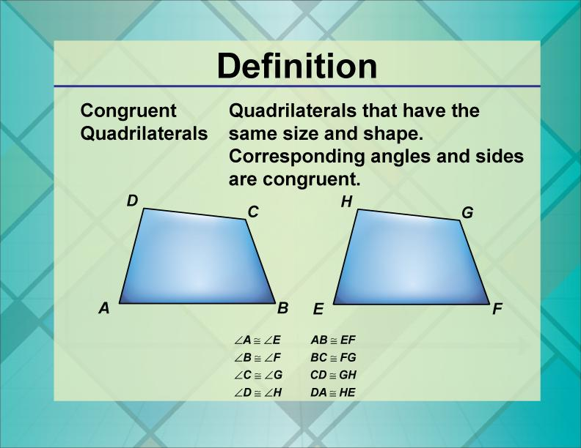
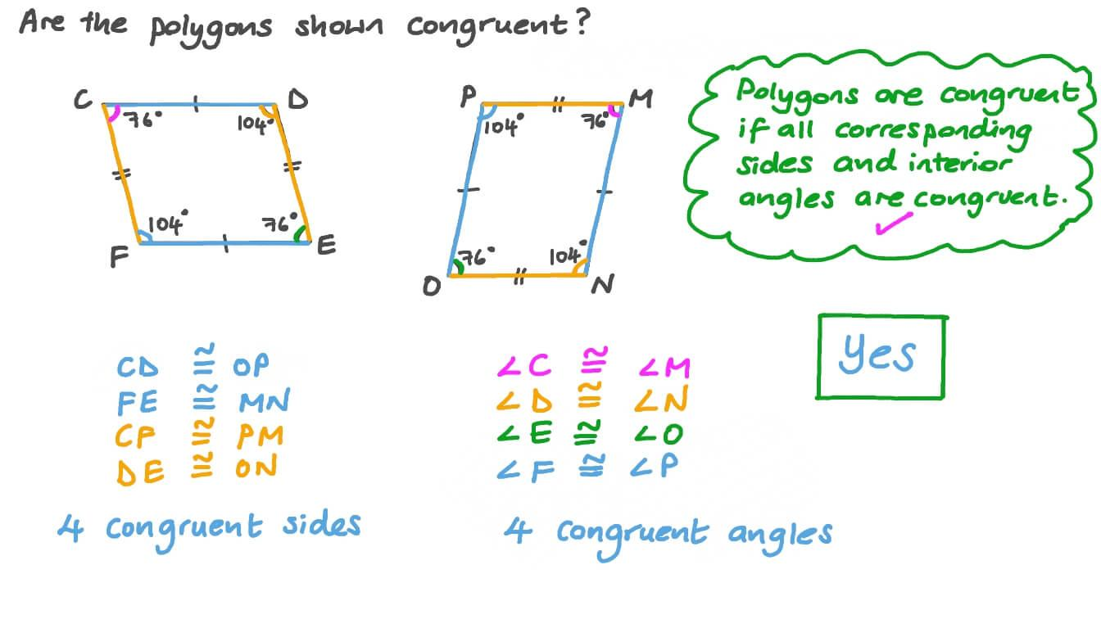
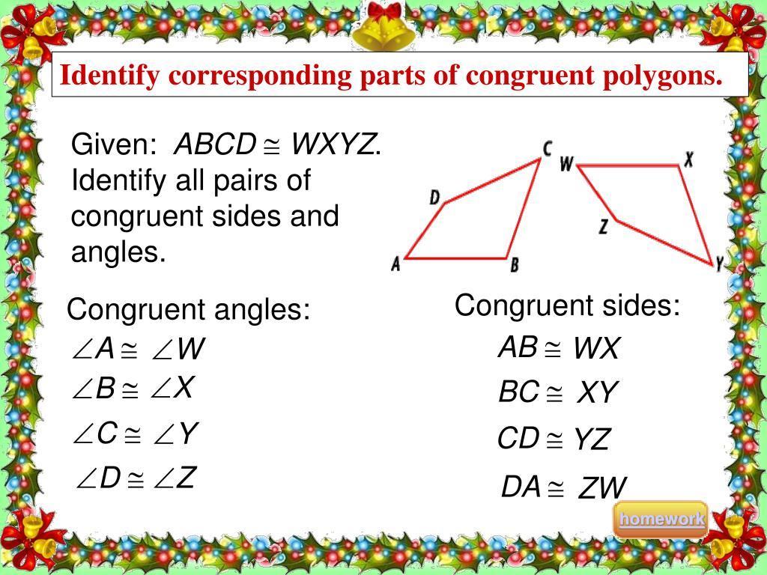
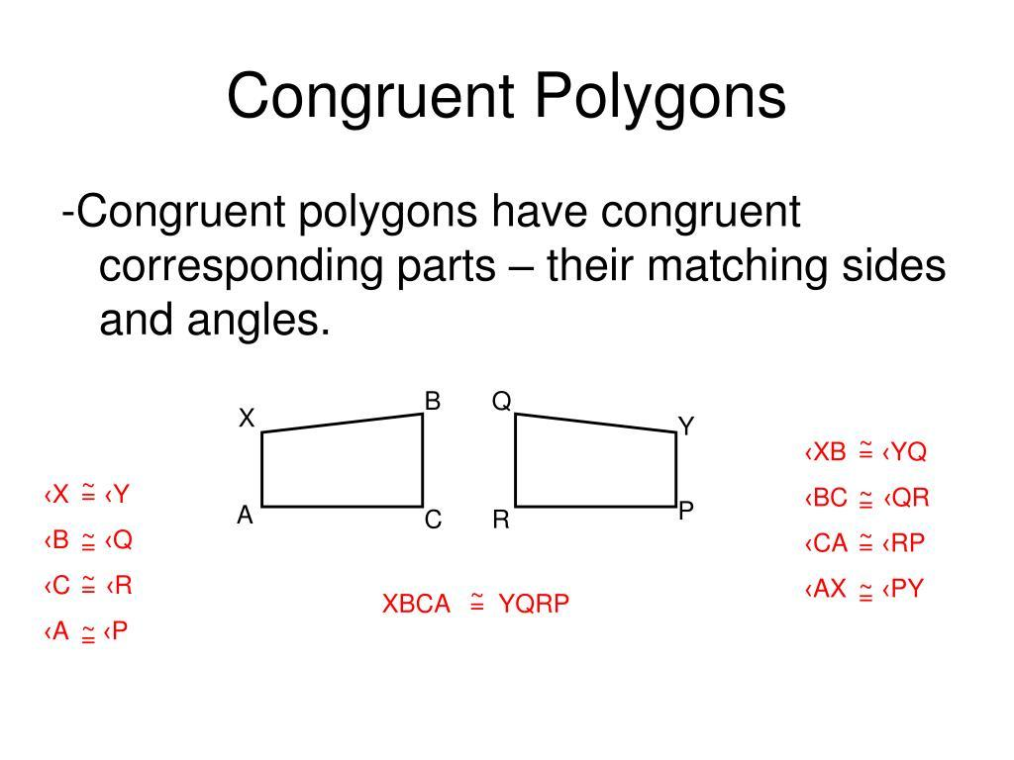
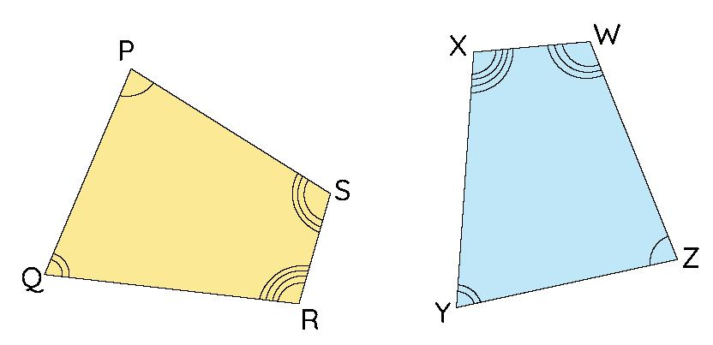

Equality from Congruent Rectangles
# Source: AI Source: Provided by: [Data Path: Persons Table -> ID Column: 1, Name_En Column: Motasem Essam] -> From: [ChatGPT] on [7/25/2026]
If two rectangles are congruent, their corresponding dimensions are equal.
For example:
$$R_{1}≅R_{2}.$$
Then:
$$\boxed{l_{1}=l_{2}}$$
and:
$$\boxed{w_{1}=w_{2}}.$$
Their areas and perimeters are also equal:
$$\boxed{A_{1}=A_{2}} \\ \boxed{P_{1}=P_{2}}.$$

Equality from Congruent Squares
# Source: AI Source: Provided by: [Data Path: Persons Table -> ID Column: 1, Name_En Column: Motasem Essam] -> From: [ChatGPT] on [7/25/2026]
Congruent squares have equal corresponding sides.
If:
$$S_{1}≅S_{2},$$
then:
$$\boxed{s_{1}=s_{2}}.$$
Since:
$$A=s^{2}$$
and:
$$P=4s,$$
they also have:
$$\boxed{A_{1}=A_{2}}$$
and:
$$\boxed{P_{1}=P_{2}}.$$

Equality from Congruent Circles
# Source: AI Source: Provided by: [Data Path: Persons Table -> ID Column: 1, Name_En Column: Motasem Essam] -> From: [ChatGPT] on [7/25/2026]
Two congruent circles have equal radii:
$$\boxed{C_{1}≅C_{2}⇒r_{1}=r_{2}}.$$
They consequently have equal diameters:
$$\boxed{d_{1}=d_{2}}$$
equal circumferences:
$$\boxed{C_{1}=C_{2}}$$
and equal areas:
$$\boxed{A_{1}=A_{2}}.$$
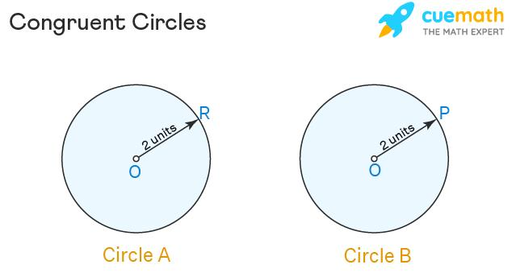
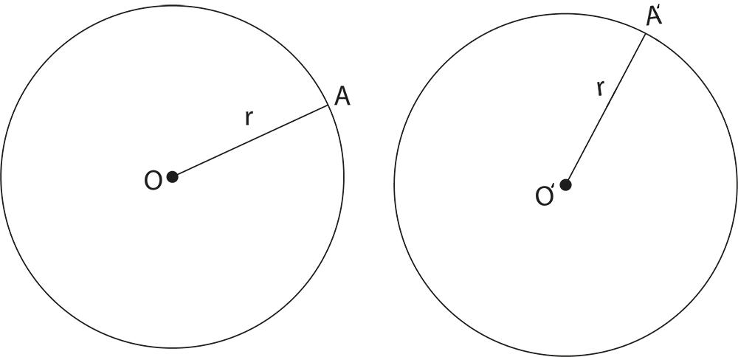
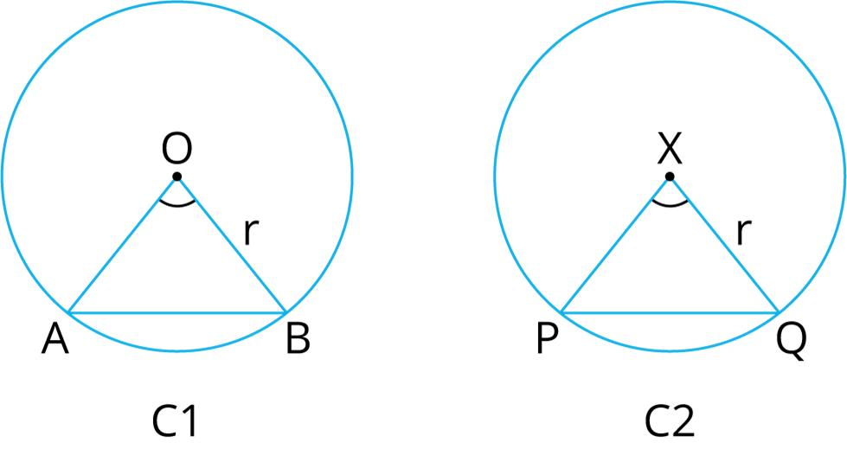
For circles, equal radius is also sufficient for congruence:
$$\boxed{r_{1}=r_{2} ⟺ C_{1}≅C_{2}}.$$

Equality of Areas from Congruence
# Source: AI Source: Provided by: [Data Path: Persons Table -> ID Column: 1, Name_En Column: Motasem Essam] -> From: [ChatGPT] on [7/25/2026]
Congruent figures always have equal areas:
$$\boxed{F_{1}≅F_{2}⇒A_{1}=A_{2}}.$$
Example
Two congruent rectangles each have:
$$l=8, w=5.$$
Therefore:
$$A=8\left(5\right)=40.$$
So:
$$\boxed{A_{1}=A_{2}=40}.$$
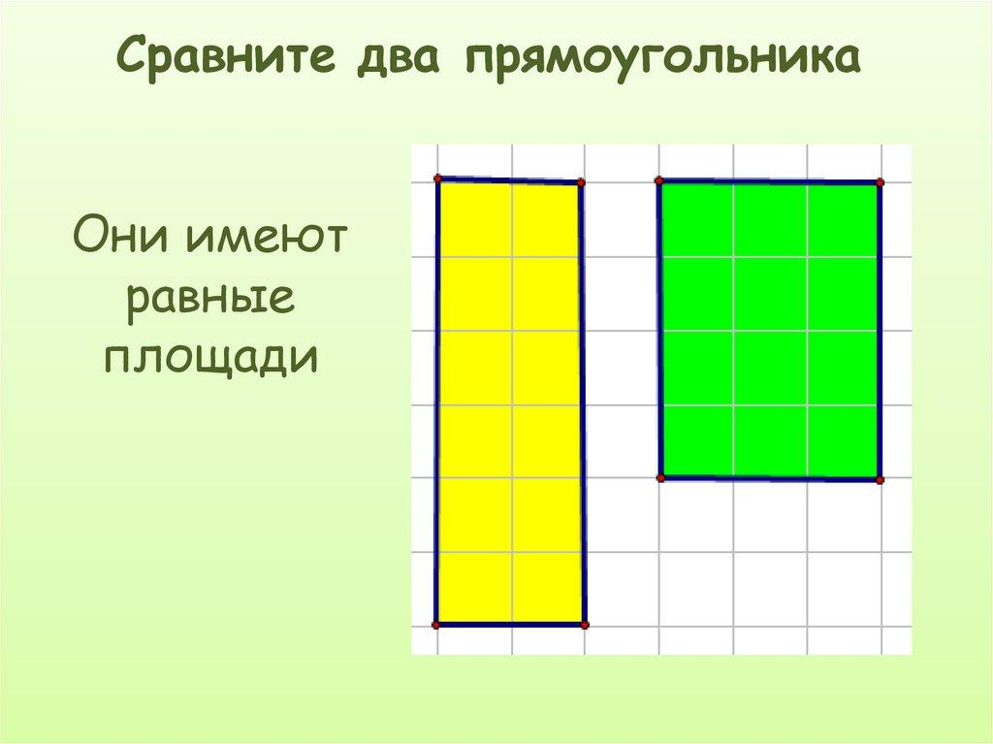
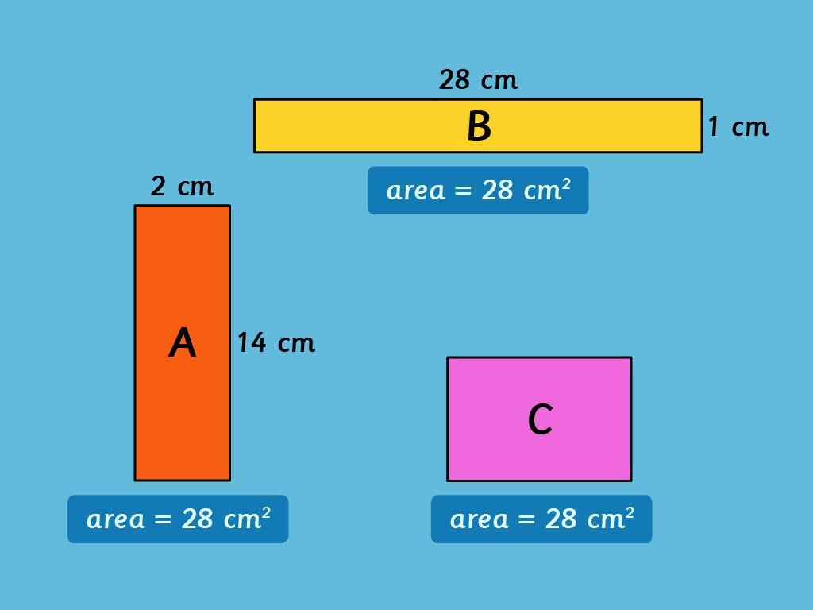
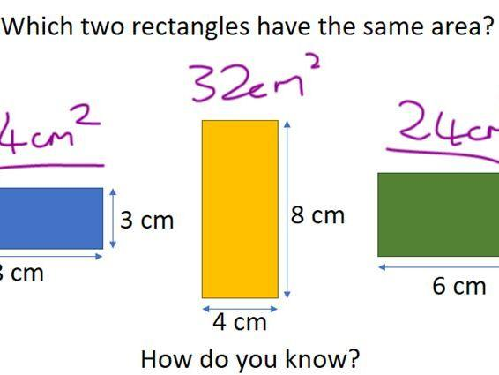

Equality of Perimeters from Congruence
# Source: AI Source: Provided by: [Data Path: Persons Table -> ID Column: 1, Name_En Column: Motasem Essam] -> From: [ChatGPT] on [7/25/2026]
Congruent figures have equal perimeters:
$$\boxed{F_{1}≅F_{2}⇒P_{1}=P_{2}}.$$
Example
Two congruent rectangles have:
$$l=10, w=4.$$
Then:
$$P=2\left(10+4\right)=28.$$
Therefore:
$$\boxed{P_{1}=P_{2}=28}.$$

Equality of Distances from Congruence
# Source: AI Source: Provided by: [Data Path: Persons Table -> ID Column: 1, Name_En Column: Motasem Essam] -> From: [ChatGPT] on [7/25/2026]
Congruence preserves corresponding distances.
If:
$$F_{1}≅F_{2},$$
then corresponding points have equal distances.
For example:
$$AB=CD.$$
If $AB$corresponds to $CD$, then their distance/length measurements are equal.
This is fundamentally connected to the fact that congruence is based on distance-preserving transformations.

Equality from Isometry
# Source: AI Source: Provided by: [Data Path: Persons Table -> ID Column: 1, Name_En Column: Motasem Essam] -> From: [ChatGPT] on [7/25/2026]
An isometry is a transformation that preserves distances.
Examples:
- Translation
- Rotation
- Reflection
- Glide reflection
If:
$$F^{'}=T\left(F\right)$$
where $T$is an isometry, then:
$$\boxed{F^{'}≅F}.$$
Corresponding lengths remain equal:
$$\boxed{AB=A^{'}B^{'}}.$$
Corresponding angles remain equal:
$$\boxed{∠A=∠A^{'}}.$$
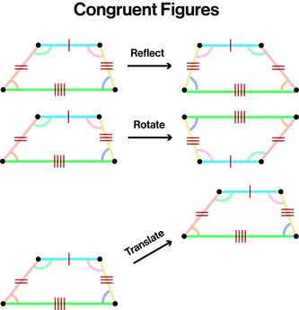
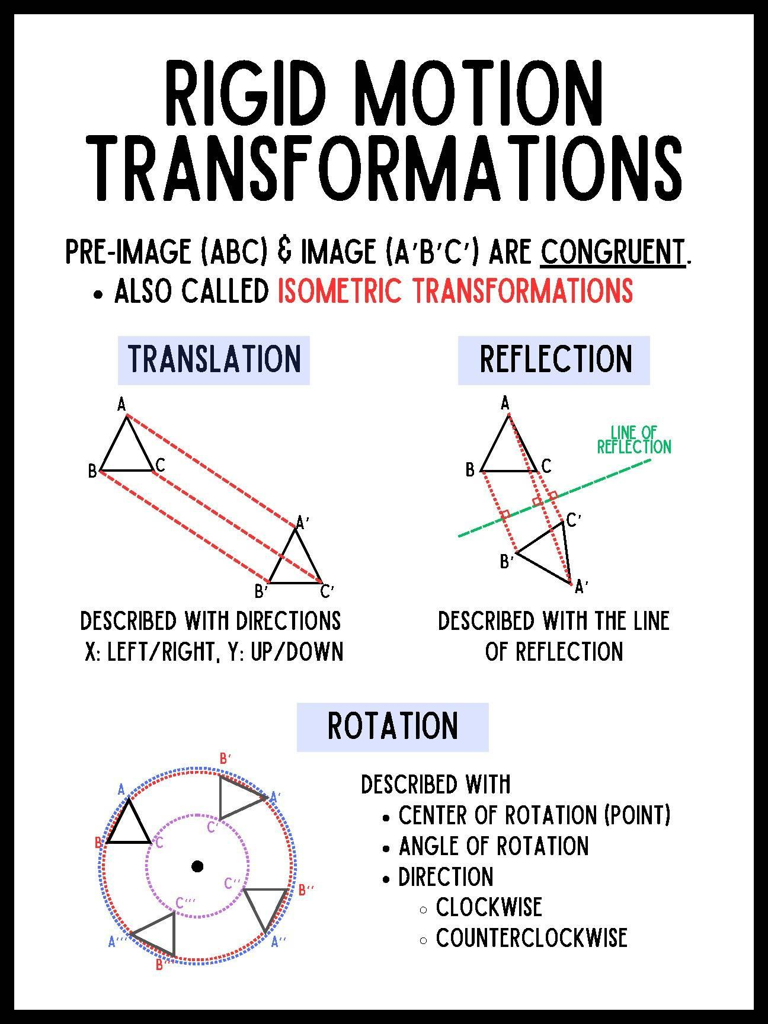
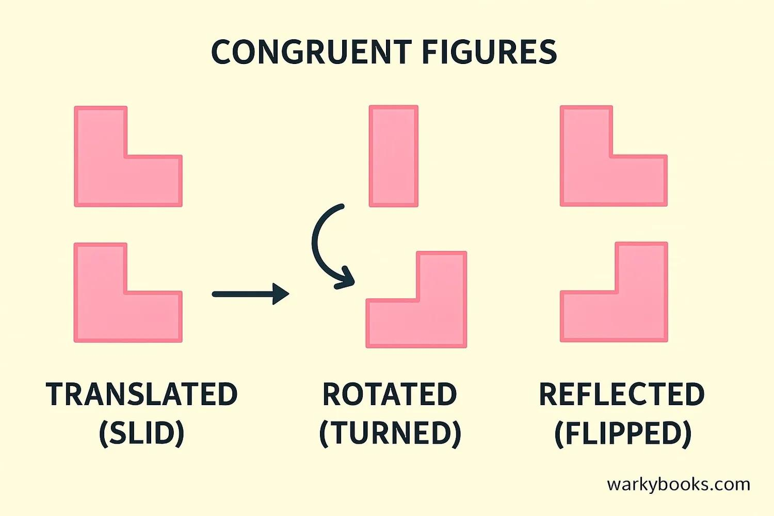
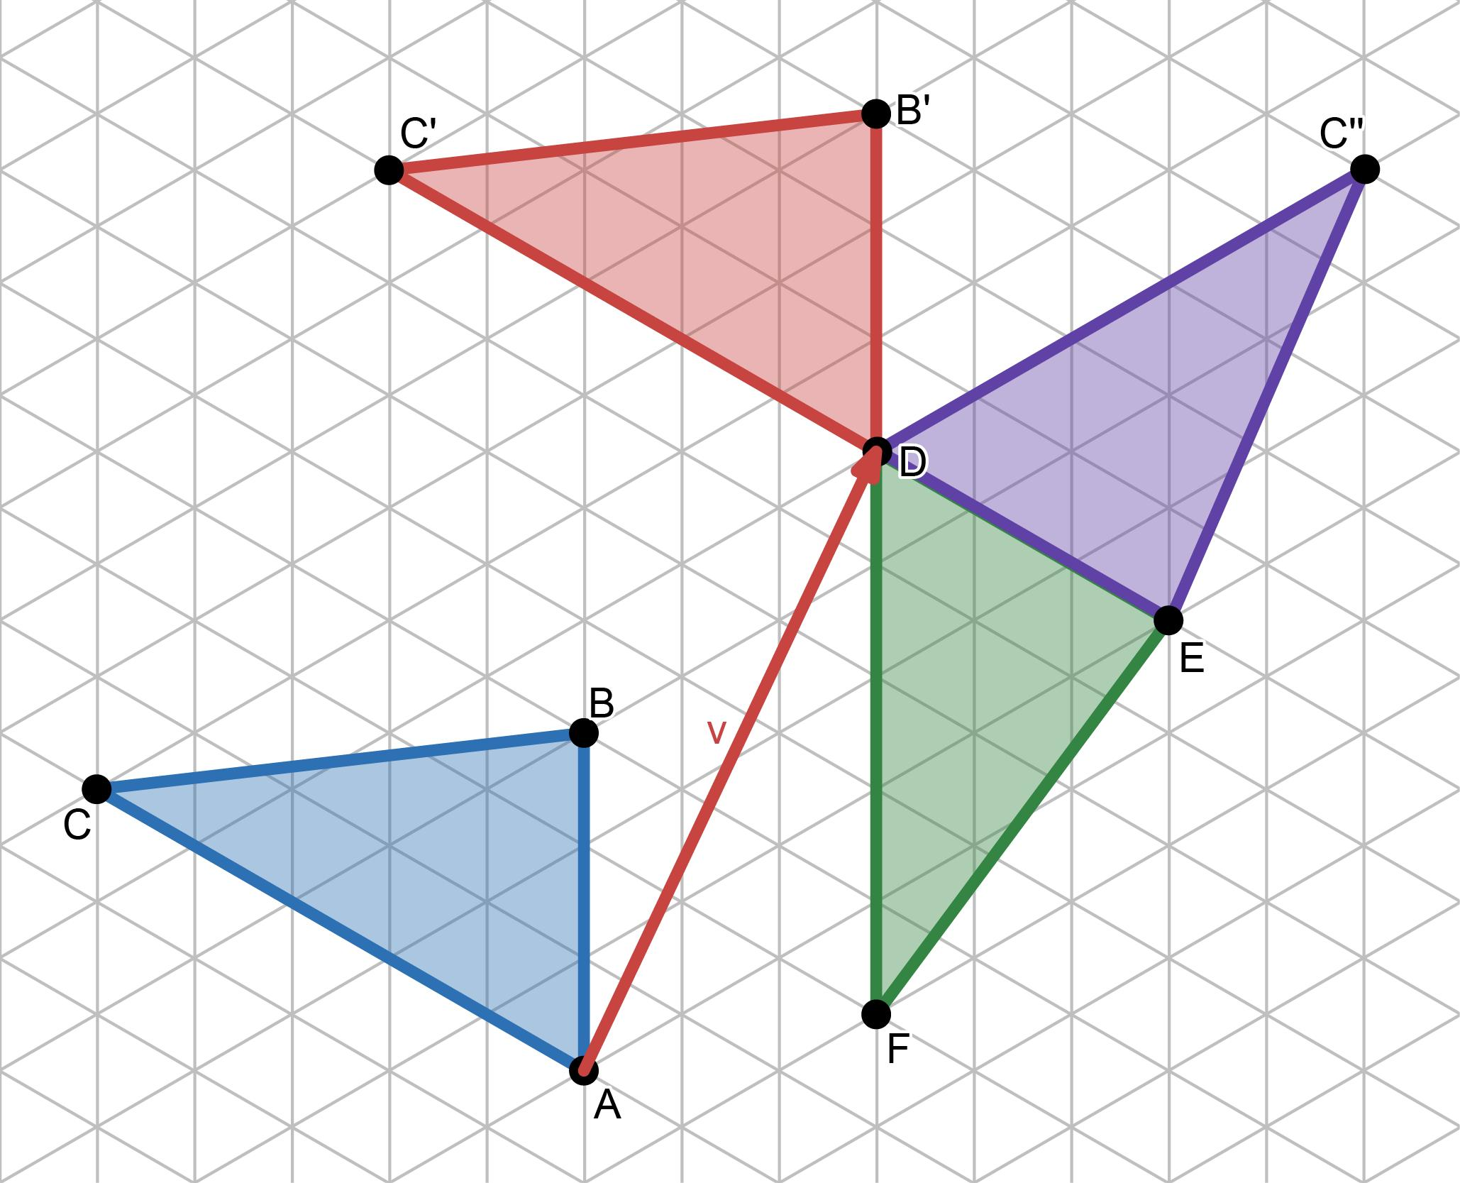

Equality from Symmetry
# Source: AI Source: Provided by: [Data Path: Persons Table -> ID Column: 1, Name_En Column: Motasem Essam] -> From: [ChatGPT] on [7/25/2026]
Symmetry is often based on an isometry that maps a figure onto itself.
For example, reflection symmetry can produce:
$$\boxed{AB=A^{'}B^{'}}$$
for corresponding reflected segments.
Similarly, rotational symmetry can map one side or angle to another equal side or angle.
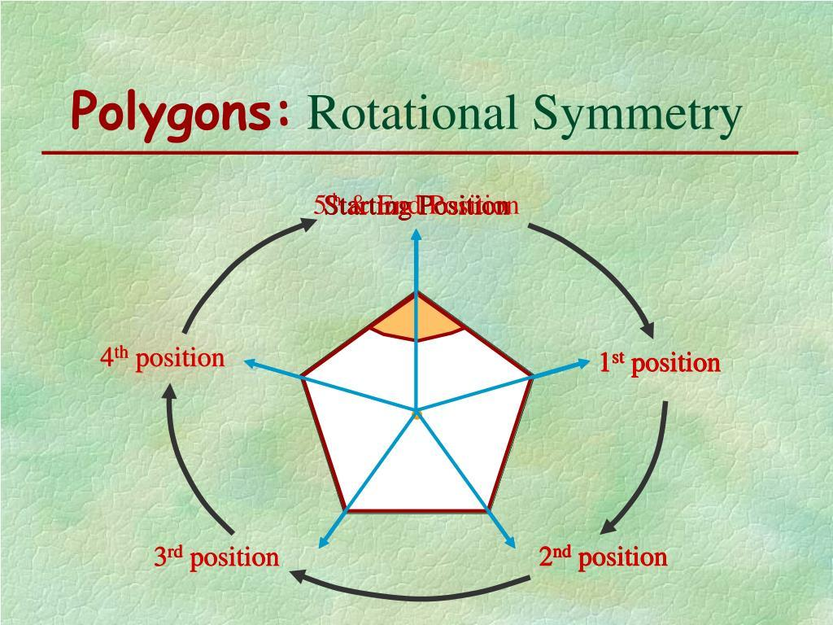
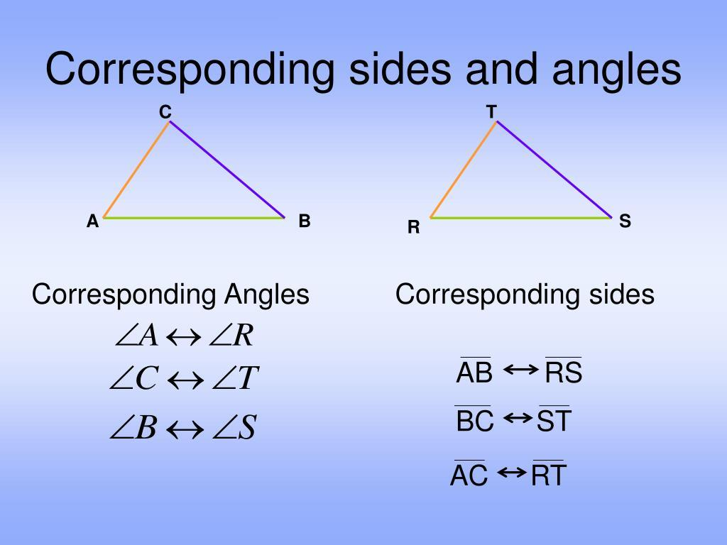
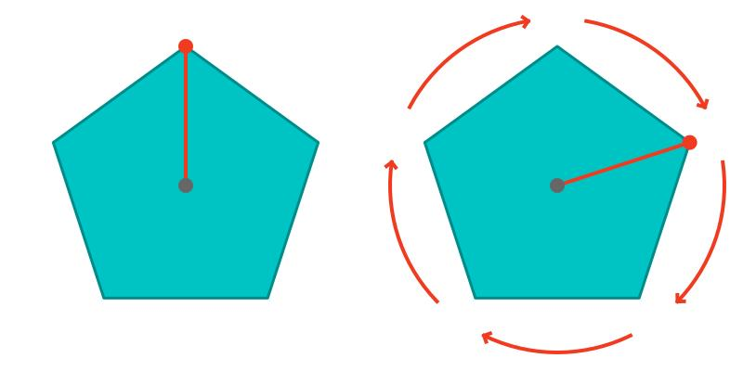

Equality from Congruent Arcs
# Source: AI Source: Provided by: [Data Path: Persons Table -> ID Column: 1, Name_En Column: Motasem Essam] -> From: [ChatGPT] on [7/25/2026]
In circle geometry, congruent arcs have equal measures and equal arc lengths when they belong to the same circle.
For example:
$$\boxed{\hat{AB}≅\hat{CD}}$$
implies:
$$\boxed{m\hat{AB}=m\hat{CD}}.$$
If they are arcs of the same circle, equal arc measures correspond to equal arc lengths.
Equal arcs also subtend equal central angles:
$$\boxed{∠AOB=∠COD}.$$
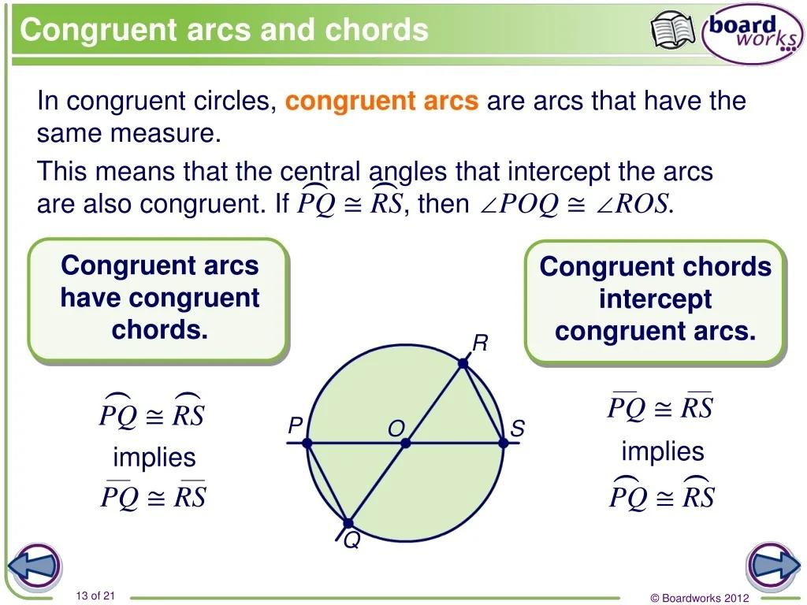
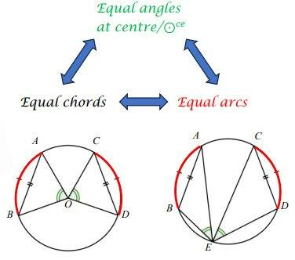
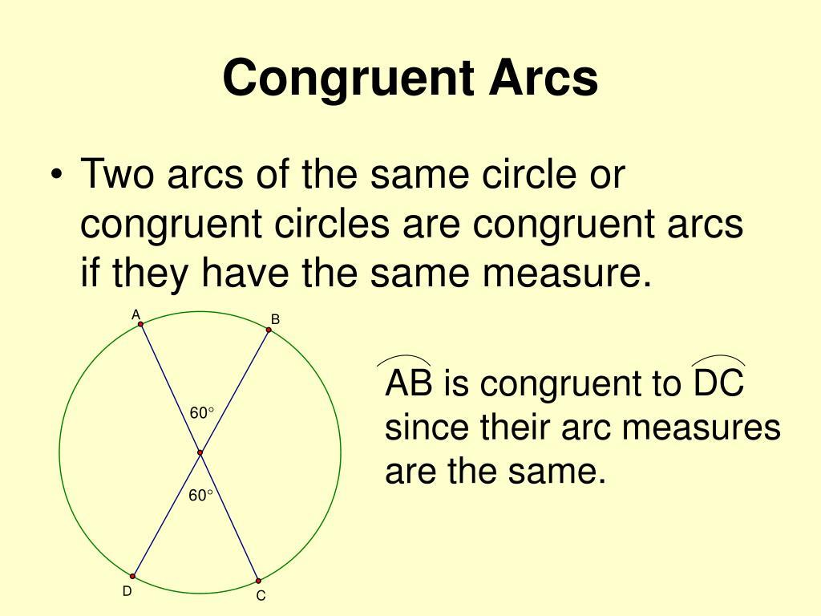
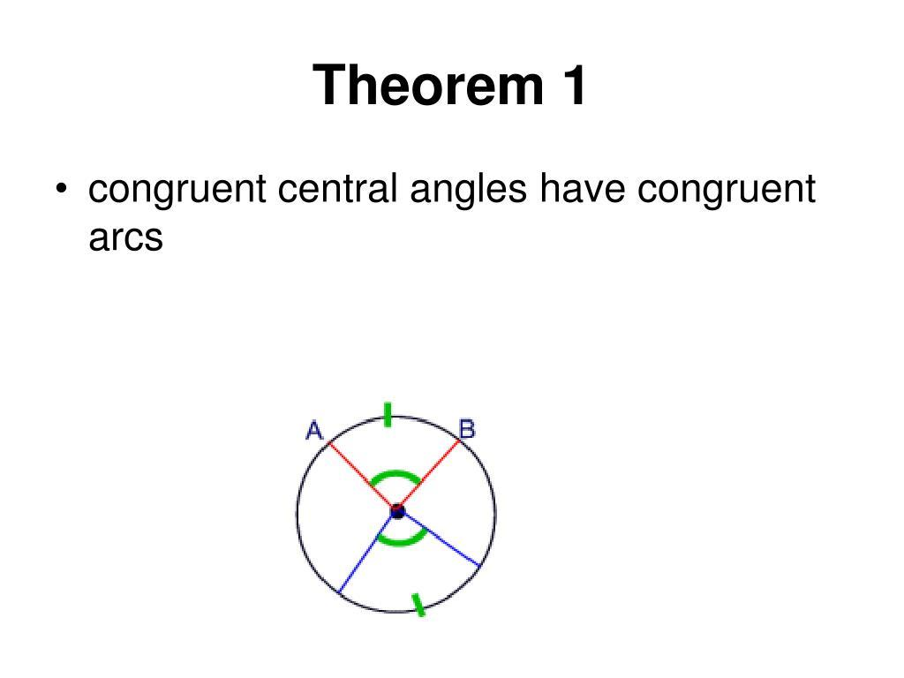
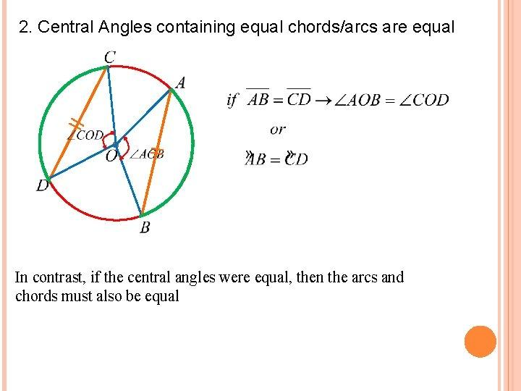

Equality from Congruent Regions
# Source: AI Source: Provided by: [Data Path: Persons Table -> ID Column: 1, Name_En Column: Motasem Essam] -> From: [ChatGPT] on [7/25/2026]
Two regions can be congruent:
$$\boxed{R_{1}≅R_{2}}.$$
Then corresponding geometric measurements are equal.
In particular:
$$\boxed{A_{1}=A_{2}}.$$
and their boundary lengths are equal:
$$\boxed{P_{1}=P_{2}}.$$
Example
Two congruent semicircular regions with radius $5$have equal areas:
$$A=\frac{1}{2}π{\left(5\right)}^{2} \\ A=\frac{25π}{2}.$$
Thus:
$$\boxed{A_{1}=A_{2}}.$$

Equality from Congruence in a Proof
# Source: AI Source: Provided by: [Data Path: Persons Table -> ID Column: 1, Name_En Column: Motasem Essam] -> From: [ChatGPT] on [7/25/2026]
Consider:
Given:
$$△ABC≅△DEF.$$
Prove:
$$AC=DF.$$
Proof
Since:
$$△ABC≅△DEF,$$
the correspondence is:
$$A↔D, B↔E, C↔F.$$
Therefore, $AC$corresponds to $DF$.
By CPCTC:
$$\boxed{AC=DF}.$$
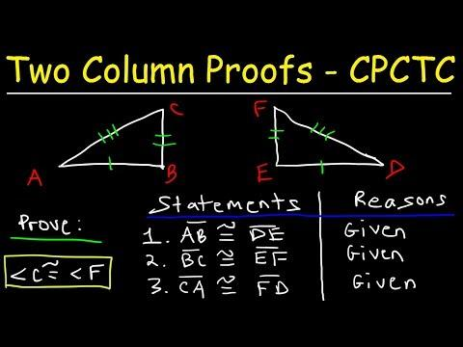
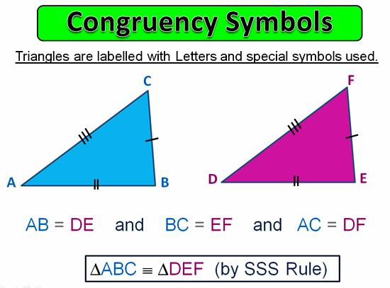
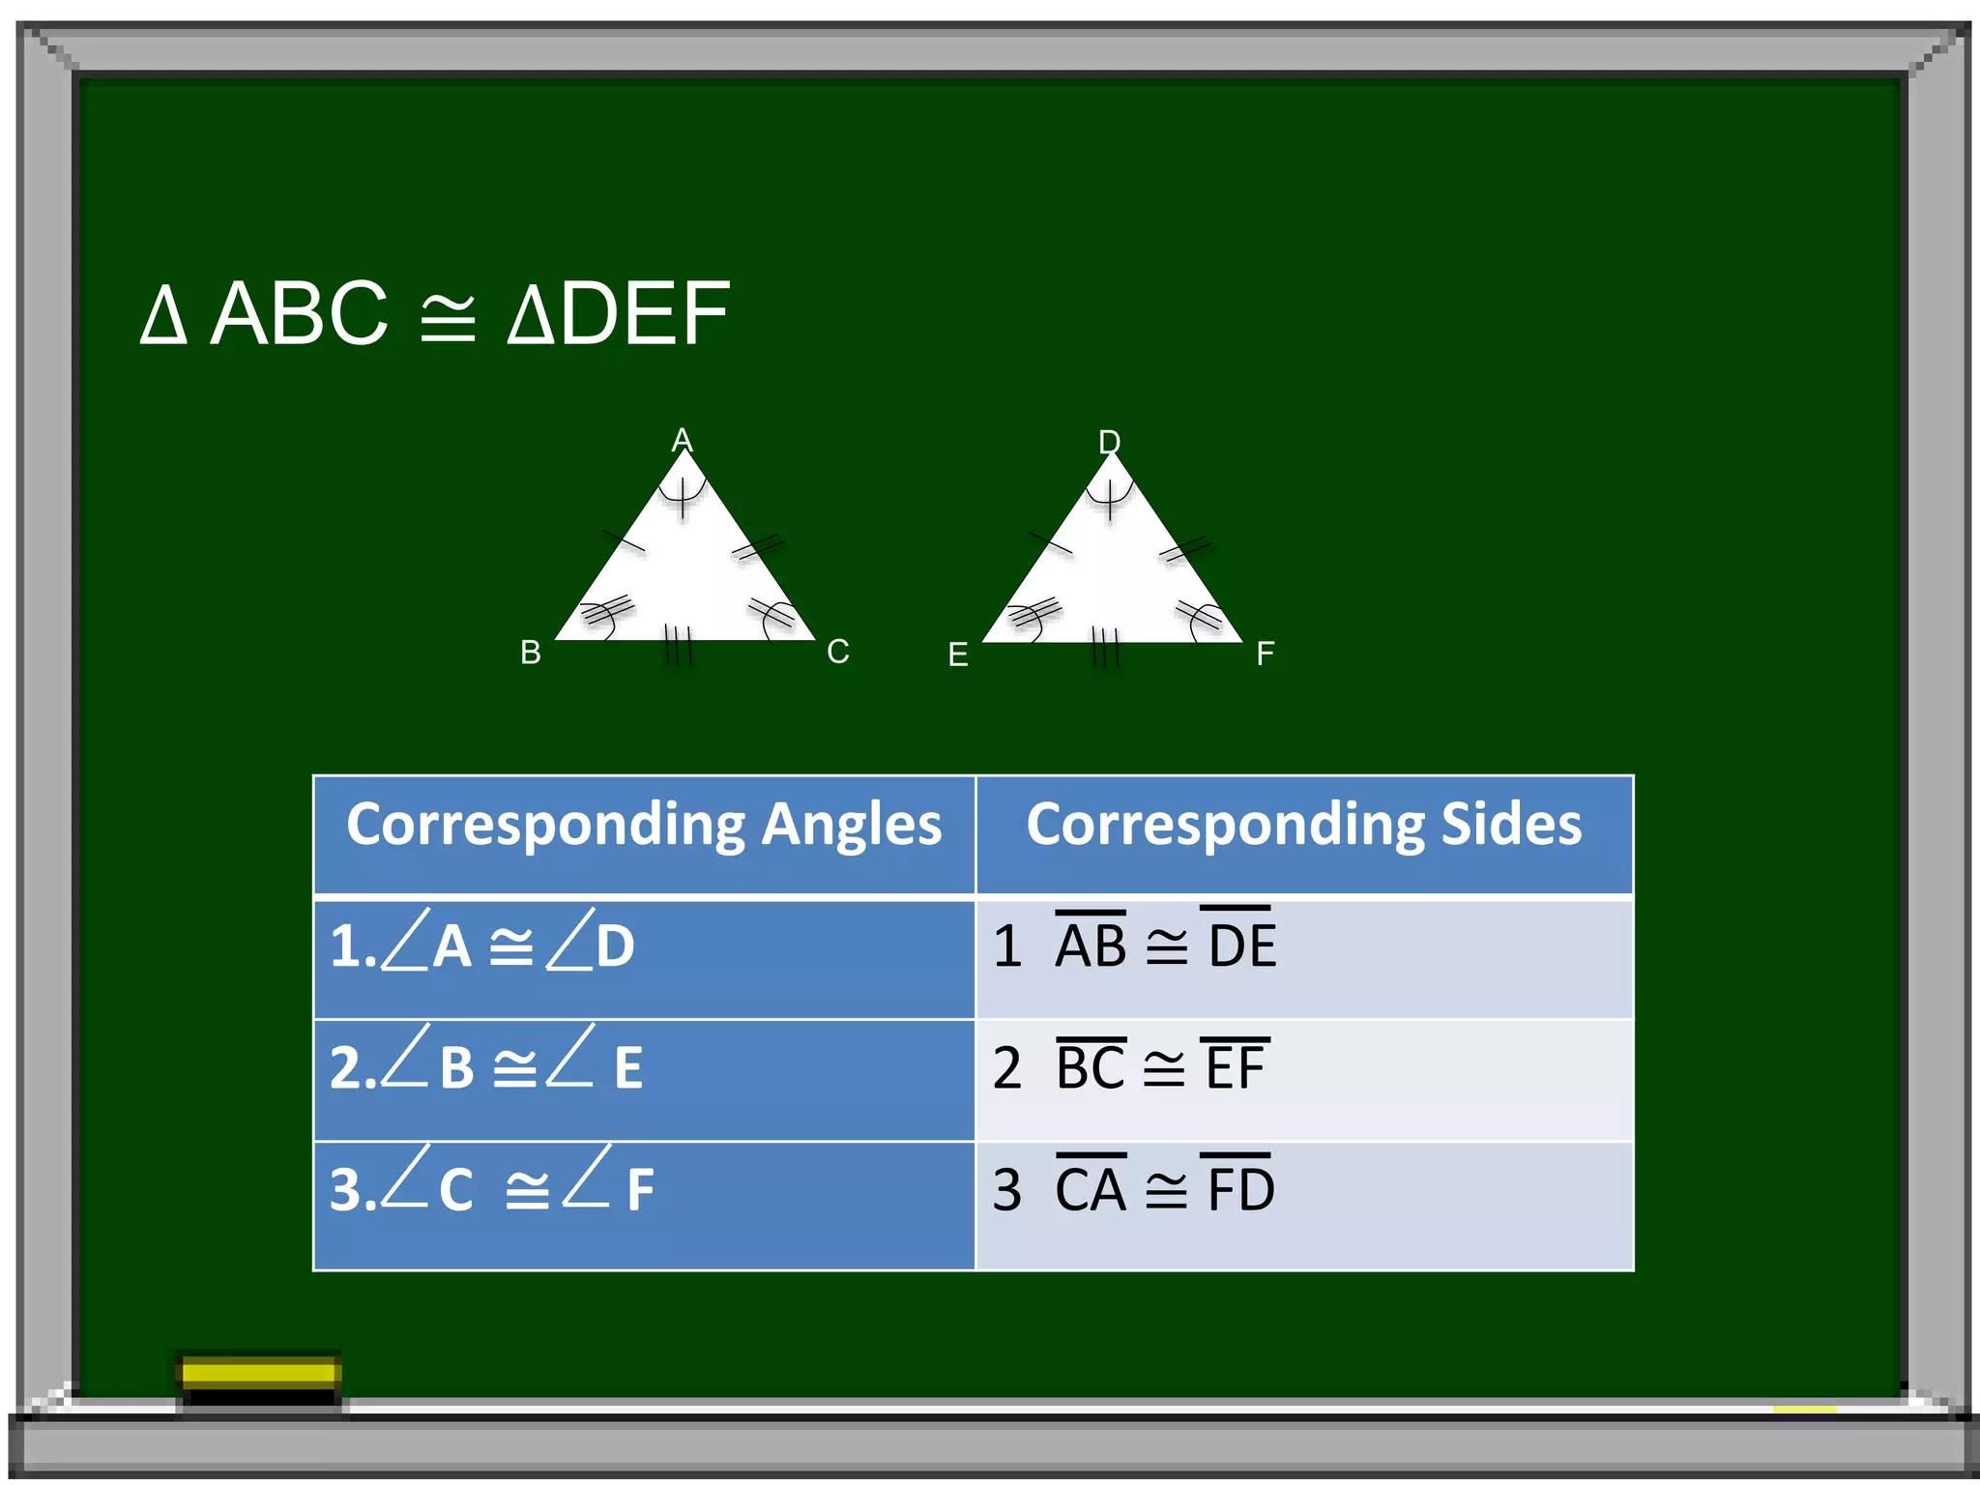

Equality from Congruence and Algebra
# Source: AI Source: Provided by: [Data Path: Persons Table -> ID Column: 1, Name_En Column: Motasem Essam] -> From: [ChatGPT] on [7/25/2026]
Congruence can produce equations that can then be solved algebraically.
Suppose:
$$△ABC≅△DEF.$$
Therefore:
$$AB=DE.$$
Suppose:
$$AB=3x+2$$
and:
$$DE=5x-10.$$
Then:
$$3x+2=5x-10.$$
So:
$$12=2x \\ x=6.$$
Thus:
$$AB=DE=20.$$
The reasoning chain is:
$$\boxed{\text{Congruence}→\text{Corresponding Equality}→\text{Equation}→\text{Solution}}$$

Equality from Congruence and CPCTC
# Source: AI Source: Provided by: [Data Path: Persons Table -> ID Column: 1, Name_En Column: Motasem Essam] -> From: [ChatGPT] on [7/25/2026]
A typical proof structure is:
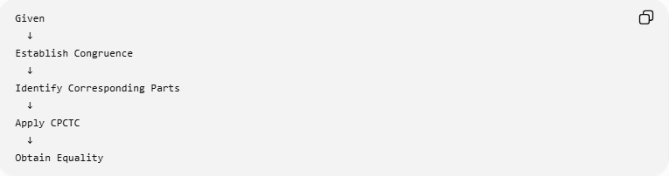
Given
↓
Establish Congruence
↓
Identify Corresponding Parts
↓
Apply CPCTC
↓
Obtain Equality
For example:
$$△ABC≅△DEF$$
then:
$$AB=DE \\ BC=EF \\ AC=DF$$
and:
$$∠A=∠D \\ ∠B=∠E \\ ∠C=∠F.$$

Congruence vs Equality
# Source: AI Source: Provided by: [Data Path: Persons Table -> ID Column: 1, Name_En Column: Motasem Essam] -> From: [ChatGPT] on [7/25/2026]
These concepts are closely related but not identical.
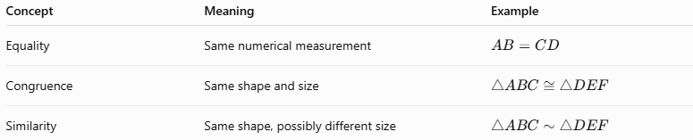
Concept | Meaning | Example
Equality | Same numerical measurement | $$AB=CD$$
Congruence | Same shape and size | $$△ABC≅△DEF$$
Similarity | Same shape, possibly different size | $$△ABC∼△DEF$$
Important relationship
$$\boxed{\text{Congruence}⇒\text{Corresponding Equality}}$$
but:
$$\boxed{\text{Corresponding Equality}⇏\text{Congruence}}$$
in general.
For example, two triangles can have:
$$AB=DE$$
without the entire triangles being congruent.

Congruence vs Similarity
# Source: AI Source: Provided by: [Data Path: Persons Table -> ID Column: 1, Name_En Column: Motasem Essam] -> From: [ChatGPT] on [7/25/2026]
For congruent figures:
$$\boxed{k=1}.$$
For similar figures:
$$\boxed{k≠1}$$
is possible.
For corresponding lengths of similar figures:
$$\frac{AB}{DE}=k.$$
For congruent figures:
$$AB=DE,$$
so:
$$\frac{AB}{DE}=1.$$
Thus congruence can be regarded as the unit-scale case of similarity, while the two concepts are still normally treated separately.

Congruence Guarantees Several Equalities
# Source: AI Source: Provided by: [Data Path: Persons Table -> ID Column: 1, Name_En Column: Motasem Essam] -> From: [ChatGPT] on [7/25/2026]
If:
$$F_{1}≅F_{2},$$
then, for corresponding quantities:
$$\boxed{{\text{Length}}_{1}={\text{Length}}_{2}} \\ \boxed{{\text{Angle}}_{1}={\text{Angle}}_{2}} \\ \boxed{{\text{Area}}_{1}={\text{Area}}_{2}} \\ \boxed{{\text{Perimeter}}_{1}={\text{Perimeter}}_{2}}.$$
For circles:
$$\boxed{r_{1}=r_{2}} \\ \boxed{d_{1}=d_{2}} \\ \boxed{C_{1}=C_{2}} \\ \boxed{A_{1}=A_{2}}.$$

Classification Summary
# Source: AI Source: Provided by: [Data Path: Persons Table -> ID Column: 1, Name_En Column: Motasem Essam] -> From: [ChatGPT] on [7/25/2026]
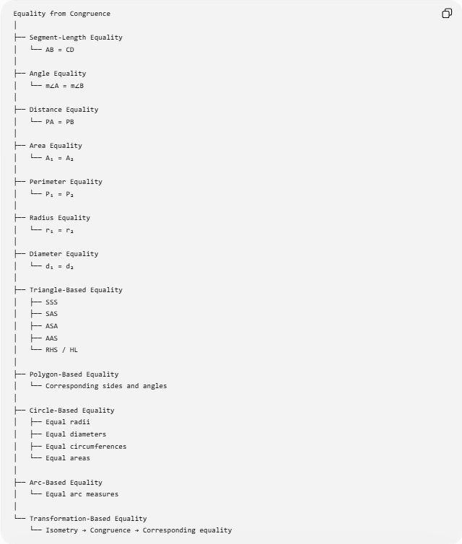
Equality from Congruence
│
├── Segment-Length Equality
│ └── AB = CD
│
├── Angle Equality
│ └── m∠A = m∠B
│
├── Distance Equality
│ └── PA = PB
│
├── Area Equality
│ └── A₁ = A₂
│
├── Perimeter Equality
│ └── P₁ = P₂
│
├── Radius Equality
│ └── r₁ = r₂
│
├── Diameter Equality
│ └── d₁ = d₂
│
├── Triangle-Based Equality
│ ├── SSS
│ ├── SAS
│ ├── ASA
│ ├── AAS
│ └── RHS / HL
│
├── Polygon-Based Equality
│ └── Corresponding sides and angles
│
├── Circle-Based Equality
│ ├── Equal radii
│ ├── Equal diameters
│ ├── Equal circumferences
│ └── Equal areas
│
├── Arc-Based Equality
│ └── Equal arc measures
│
└── Transformation-Based Equality
└── Isometry → Congruence → Corresponding equality

Relationship to Geometric Equality
# Source: AI Source: Provided by: [Data Path: Persons Table -> ID Column: 1, Name_En Column: Motasem Essam] -> From: [ChatGPT] on [7/25/2026]
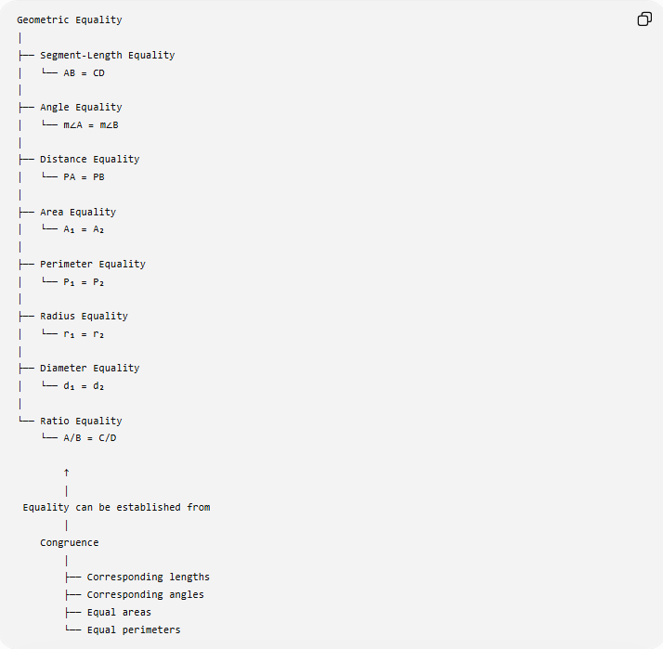
Geometric Equality
│
├── Segment-Length Equality
│ └── AB = CD
│
├── Angle Equality
│ └── m∠A = m∠B
│
├── Distance Equality
│ └── PA = PB
│
├── Area Equality
│ └── A₁ = A₂
│
├── Perimeter Equality
│ └── P₁ = P₂
│
├── Radius Equality
│ └── r₁ = r₂
│
├── Diameter Equality
│ └── d₁ = d₂
│
└── Ratio Equality
└── A/B = C/D

↑
│
Equality can be established from
│
Congruence
│
├── Corresponding lengths
├── Corresponding angles
├── Equal areas
└── Equal perimeters

Key Principles
# Source: AI Source: Provided by: [Data Path: Persons Table -> ID Column: 1, Name_En Column: Motasem Essam] -> From: [ChatGPT] on [7/25/2026]
Principle 1 — Congruence gives corresponding equality
$$\boxed{F_{1}≅F_{2}⇒\text{corresponding measurements are equal}}$$
Principle 2 — Triangle congruence gives CPCTC
$$\boxed{△ABC≅△DEF⇒\text{corresponding parts are congruent}}$$
Principle 3 — Congruent figures have equal area
$$\boxed{F_{1}≅F_{2}⇒A_{1}=A_{2}}$$
Principle 4 — Congruent figures have equal perimeter
$$\boxed{F_{1}≅F_{2}⇒P_{1}=P_{2}}$$
Principle 5 — Congruent circles have equal radii
$$\boxed{C_{1}≅C_{2}⇒r_{1}=r_{2}}$$
Principle 6 — Isometries produce congruence
$$\boxed{\text{Isometry}⇒\text{Congruence}⇒\text{Corresponding Equality}}$$

Key Points
# Source: AI Source: Provided by: [Data Path: Persons Table -> ID Column: 1, Name_En Column: Motasem Essam] -> From: [ChatGPT] on [7/25/2026]
- Equality from Congruence means obtaining equality from a congruence relationship.
- Congruent objects have the same shape and size.
- Corresponding lengths are equal.
- Corresponding angles are equal.
- Congruent regions have equal areas.
- Congruent figures have equal perimeters.
- Congruent circles have equal radii and diameters.
- For triangles, CPCTC is the standard mechanism for obtaining corresponding equalities.
- SSS, SAS, ASA, AAS, and RHS/HL can establish triangle congruence.
- Congruence is stronger than equality of one isolated measurement.
- Equal corresponding measurements alone generally do not establish congruence.
- Isometries preserve lengths and angles and therefore produce congruent figures.
- Congruence is distinct from similarity:
$$\boxed{\text{Congruence}=\text{same shape + same size}} \\ \boxed{\text{Similarity}=\text{same shape + proportional size}}$$

Conclusion
# Source: AI Source: Provided by: [Data Path: Persons Table -> ID Column: 1, Name_En Column: Motasem Essam] -> From: [ChatGPT] on [7/25/2026]
Equality from Congruence is the process of obtaining exact geometric equalities from a congruence relationship.
The central relationship is:
$$\boxed{\text{Congruence}→\text{Corresponding Parts}→\text{Equality}}$$
For triangles:
$$\boxed{△ABC≅△DEF⇒AB=DE, BC=EF, AC=DF}$$
and:
$$\boxed{∠A=∠D, ∠B=∠E, ∠C=∠F}$$
through CPCTC.
More generally:
$$\boxed{\text{Congruence}⇒\left\{\begin{matrix}\text{Equal corresponding lengths} \\ \text{Equal corresponding angles} \\ \text{Equal areas} \\ \text{Equal perimeters} \\ \text{Equal radii/diameters for circles}\end{matrix}\right.}$$
Therefore, Equality from Congruence is a major way of establishing Segment-Length Equality, Angle Equality, Area Equality, Perimeter Equality, Radius Equality, Diameter Equality, and other corresponding geometric equalities.

